

Capstone Project Report

An Event Hosting Mobile Application - HngOut:

by  
  
*Mohammad Rayhan  
(20070835)*  
  
*BSc (Hons) Information Technology (Computer Networking & Security)*

**Supervisor: Ms. Lim Woan Ning  
Date : 20th July 2023**

## Abstract

The COVID-19 pandemic has brought about a significant change in the way people interact and engage in social gatherings. With the easing of restrictions, individuals are looking to rebuild their social lives and meet new people. However, finding groups with similar interests has become more challenging than ever. This project aims to develop an event planning app that enables users to create, join, and plan events, facilitating the discovery of like-minded individuals with similar interests. The app will provide a platform for users to engage in social activities and meet new people, bridging the gap created by social distancing. This project seeks to address the gap in the Malaysian app market by providing a high-quality app that allows users to create and join events based on their interests, creating a vibrant and active community. The development of such an app has the potential to revolutionize the way people connect and interact, providing a platform for individuals to expand their social circles and engage in meaningful interactions.

Table of Contents

Abstract 2

**1. 0 Introduction 5**

1.1 Problem Statement 5

1.2 Projects Objectives 5

1.3 Project Scope 5

**2.0 Literature Review 6**

2.1 Meetup App 6

2.2 Eventbrite 9

2.3 All Events in City 12

2.4 Conclusion 15

**3.0 Methodology 16**

3.1 Capstone 16

3.1.1 Capstone 1 16

3.1.2 Capstone 2 20

3.2 Risk Analysis 25

3.3 Gantt Chart 28

**4.0 Methodology 30**

4.1 System Requirements 30

4.2 Related Tools and Technologies 31

4.2.1 Back - End (Java) 31

4.2.2 Front - End (Android Studio) 31

4.2.3 Database (Firebase) 31

4.2.4 Figma 31

4.3 User Interface Prototype 32

1. Main Page (First Page) 32

2.. Log in or Sign Up Page 33

3. Sign Up Type Page 34

4. Sign Up Page 35

5. Set location page 36

6. Login page 37

7. Create Event Page (Event Organizer) 38

8. Set Event Location. 39

9. My Events Page (Event Organizer) 40

10. Event Members Pop up 41

11. Review page (Event Organizer) 41

12. Home Page (Members) 42

13. Explore Page (Members) 43

14. Event Information Page (Member) 44

15. “My Events Page” (Member) 45

16. View Ticket Page Member 46

17. Review Page (Member) 47

18. Profile page 48

4.3.1 Navigation graph of User Interface Prototype 49

4.4 System Architecture 49

4.5 Model Diagrams 50

4.5.1 Data Flow Diagram 50

4.5.2 Use Case Diagram 51

4.5.3 Class Diagrams 52

4.5.4 Entity Relationship Diagram 53

4.5.5 Data Dictionary 53

4.6 Test Cases 58

4.6.1 Login Page 58

4.6.1.1 Login Page (Member) 58

4.6.1.2 Login Page (Organizer) 63

4.6.2 Sign Up 68

4.6.2.1 Organizer Sign Up 68

4.6.2.2 Member Sign Up 73

4.6.3 Organizer Pages 81

4.6.3.1 “Add Event” Page 81

4.6.3.2 “My Events” Page. 85

4.6.3.3 “Reviews” Page. 87

4.6.3.4 Profile Page. 88

4.6.4 Member Pages 90

4.6.4.1 Explore Page. 90

4.6.4.2 Home Page. 93

4.6.4.3 My Events Page. 95

4.6.4.4 Profile Page. 99

**5. Conclusion and Future Work 101**

**6. References 101**

**7. Appendix 104**

# 1. 0 Introduction

## 1.1 Problem Statement

In March 2020, the COVID – 19 pandemic forced governments of countries all over the world to impose social distancing and lockdown measures. Social gatherings were halted as countries attempted to curb the spread of the virus. Physical barriers built to halt the spread of COVID-19 dramatically affected these social standards, particularly those employed to transmit trust, affinity, empathy, and respect [1]. As COVID restrictions are being eased around the world, individuals are looking to restart their social lives, meet people and make friends. However, the lack of social interaction during the past two years has made it difficult for individuals to find groups of people with similar interests to spend quality time with. A possible solution in this digital age is an app that can allow users to discover and plan events of their interests. Currently, in the app market of Malaysia (App store and Play store), there is a lack of high-quality apps that fit this description. Even the apps that are available are geared towards allowing users to sign up/ buy tickets for events planned by official organizers, not allowing users to create or join events that they can create.

## 1.2 Projects Objectives

The project aims to develop something that would facilitate users to plan/create and join events through a single mobile application. This app will provide a platform for individuals to not only meet others with similar interests but also create events so that they can physically meet up. Consequently, to attain the objective of this project, certain objectives must be met. The objectives are:

1. To develop an Android application that would enable users to host and join events.
2. The application should allow users (who signed up as organizers) to create events of their liking, and users (who have signed up members) should be able to join the event.
3. The application should show events to members based on the member's location.

## 1.3 Project Scope

An event planning application will be developed to achieve the objective of this project. The high mobility and convenience of use afforded by smartphones makes it preferable to develop a mobile app rather than a website. This app will be developed with the help of Android Studio and an Programming language called Java. These are some of the goals that are being pursued: The functionalities the proposed application must possess include:

1. Sign up or logging in to an account
2. Creating an Event (Organizer)
3. Deleting an Event (Organizer)
4. Viewing Member Reviews (Organizer)
5. Viewing events around the user’s location (Member)
6. Joining an Event (Member)
7. Rating the Event (Member)

This project will involve the creation of an **single Android app** that will allows members and organizers create and join events. Even though creation of two separate apps will be more efficient, this project will not involve creation of two separate apps (one for users and one for organizers) for two reasons. Firstly, due to the time and resources constraints and secondly as this app is not going to be published to the market and used by actual users. Since English is a widely spoken international language and the bulk of currently accessible apps and software are written in English, it has been decided that English will be the primary language of the application for this project. However

It also important to the note that the functionality and overall efficiency of the application created in this project under load from users will be undetermined as there will be limited number of testers, so some functions such as rating of events by users will not be tested to its full capacity.

# 2.0 Literature Review

In this section, existing apps that serve a similar purpose to what has been discussed in the above section will be analyzed. Identifying the app’s strengths and weaknesses will show what an app created in such a category must possess and avoid being successful.

## 2.1 Meetup App

Meetup is the most popular software for event creation and planning with over 10 million downloads on the Play Store. Meetup was originally an site founded in 2002 [2]. Initially the app allowed to organize a Meetup Day" that would be celebrated all over the world to bring people together who shared a common interest [2].

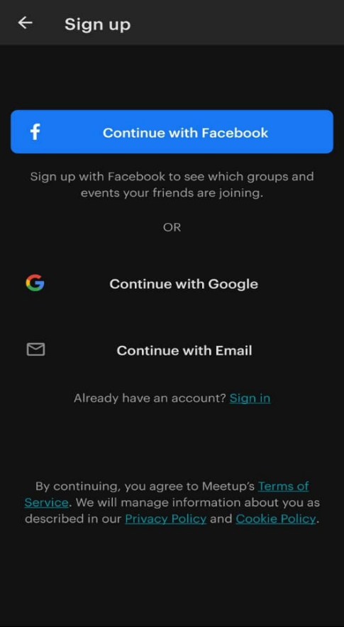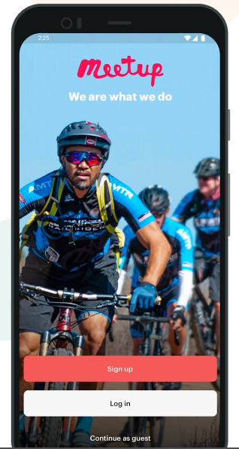

Figure 1: Meetup App Sign-up page [3] Figure 2 : Sign-Up Options for the app

The app allows users to sign up in three ways which are via Facebook account, Google Account and email (Figure 2). On sign up they ask for details such as Name, email, age and gender. The age and gender details are used to give users event suggestions that are more likely to entice them to join.

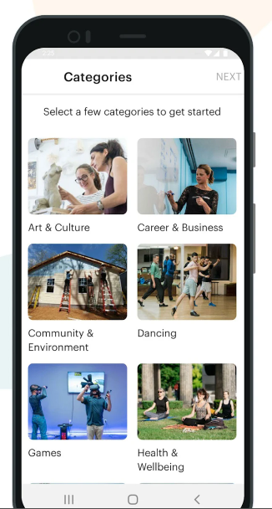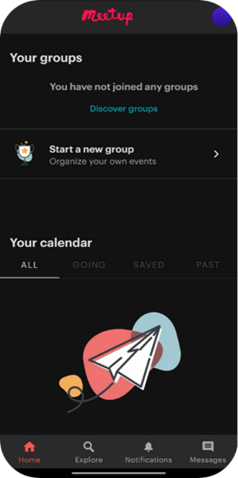

Figure 3 : Meetup App event categories [3] Figure 4: Home Page of the application [3]

Users are prompted to pick categories, which then are used to give app suggestions as seen in Figure 3. Users can then search for events or groups that they can join. The navigation bar which is located at the bottom of the screen, has 4 elements namely home, explore, notifications and messages. The home page displays current event groups the user is a part of as well as calendar of upcoming and previous events. 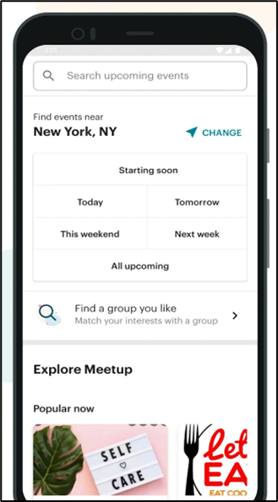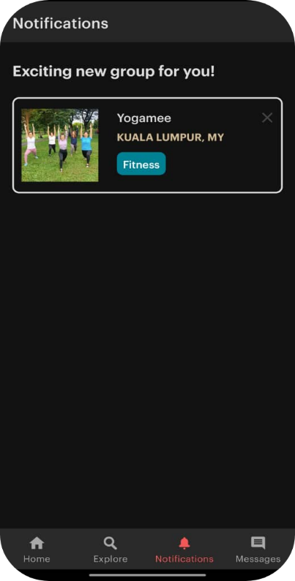

Figure 5 : Explore Page Figure 6 : Notification page

The Explore page shows users events near the users location, while allowing the user to change the location within which the events are being searched as well as to search for events based on categories as seen in Figure 5. The notifications page as seen in Figure 6, serves as a screen to notify users on upcoming events or new events which they may be interested in.

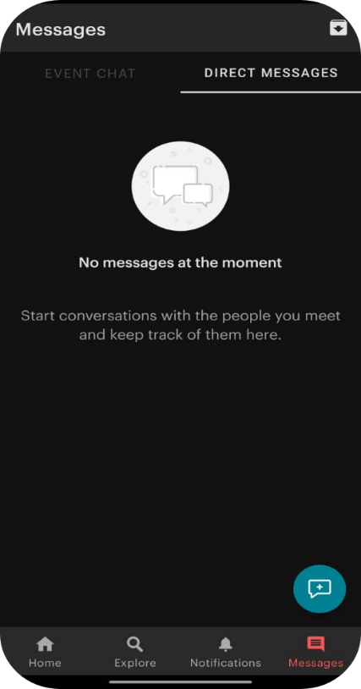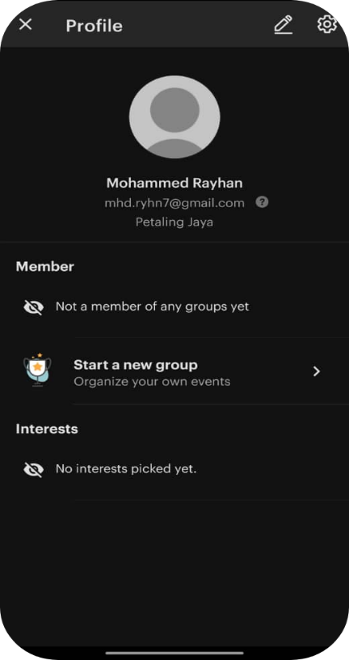

Figure 7 : Messaging page Figure 8: Profile page

The messaging page allow users to message other users on the app which they may have met during the events as well as creates a group chat for events, so the joiners of the events can talk to the organizer as well as each other as seen in Figure 7. Changes to user details and settings are made on the profile page as seen in Figure 8 which also allows users to create/start new groups.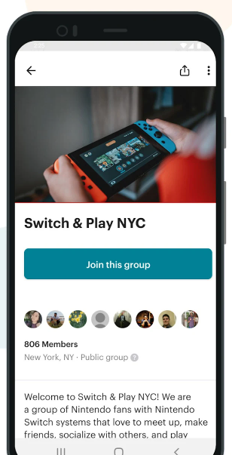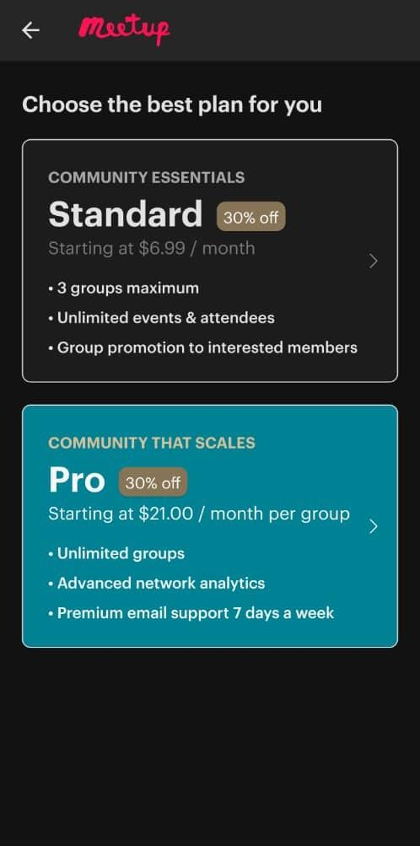

Figure 9 : An example of a sign-up screen on Meetup Figure 10: The two subscription plans

The app is free to use for people who are looking to join events. However, for organizers, they are required to pay a monthly subscription fee based on the plan they select as seen in Figure 6. There are currently two plans that organizers can choose. The Standard plan which starts at $6.99/month for a 6-month subscription and $10.99/month if the subscription is renewed on a monthly basis [4]. The Pro plan starts at $21.00/month per group created for a 6 month subscription and $24.50/month per group if the subscription is renewed on a monthly basis [4]. Payment for the above-mentioned subscription is made through card and the app has no support for E-wallets such as TNG, Grab Pay and Boost as the app geared towards the western parts of the world.

It has an average of 4.6/5 star rating based on 166,966 reviews on Play Store [3] . However, this app has limited coverage in smaller cities as there are fewer people to host events. Based on reviews, a common issue/problem users face while using the Meetup app is the email and notification spam and the difficulty of unsubscribing/disabling the emails and notifications [3,5]. Another issue users face is inability to cancel their subscription as there is no in app option to cancel the subscription. Some users have also been charged for subscription even after emailing the staff to cancel their subscription.

## 2.2 Eventbrite

The second event planning app that will be Eventbrite app which also has more than 10 million downloads on Play store. Eventbrite helps businesses arrange and sell tickets to events online and helps customers find events that spark their interests. Eventbrite hosts courses, concerts, conferences, and world-renowned film and music festivals.

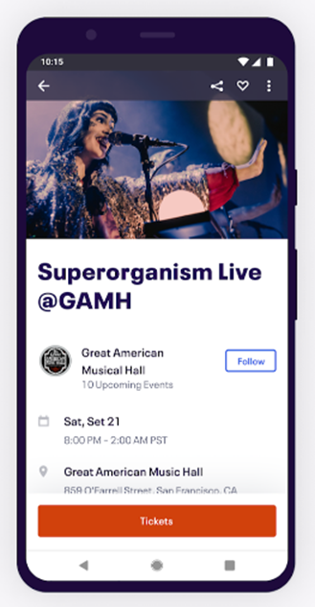

Figure 11 : Screen to buy tickets on the app [6]

Similar to the meetup app, it allows organizers to create and promote events on the app and other users to join events. However, in contrary to Meetup, Eventbrite has two apps namely Eventbrite (for user to join events and buy tickets as seen in Figure 11) and Eventbrite Organizer (for event organizers to manage and promote events).

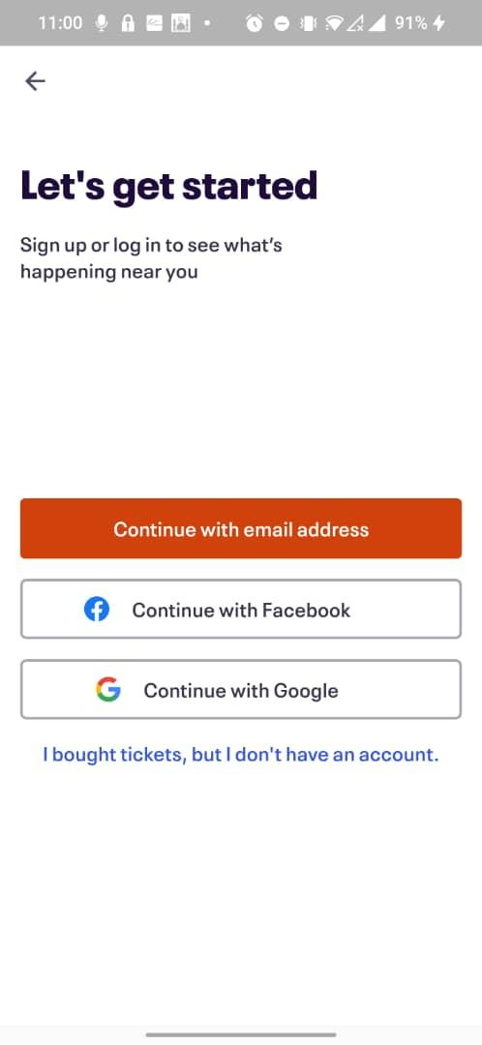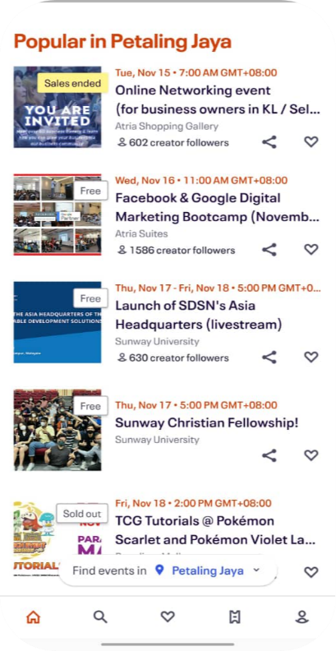

Figure 12 : Screen with Sign up options for users Figure 13 : Home Page of Application

Both the app allows users to sign up in three ways which are via Facebook account, Google Account and email as seen in Figure 12. Upon sign up users on Eventbrite can start to search for events and buy tickets for the events around, whereas event organizers can start to host events on the app upon sign up. The navigation bar which is located at the bottom of the screen, has 5 elements namely home, explore, favorites, tickets and profile. The home page displays popular events that are happening around the users location as seen in Figure 13.

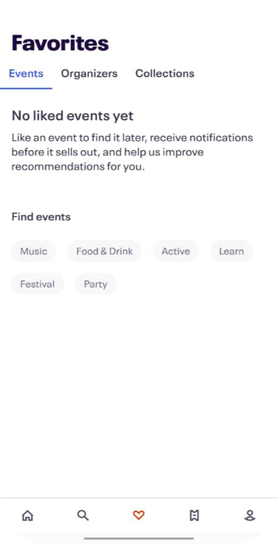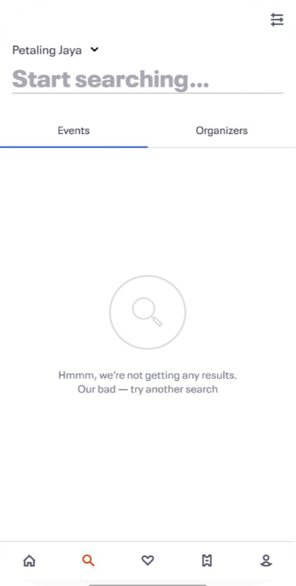

Figure 14 : Explore Page Figure 15: Favorites Page

The explore page as seen in Figure 14 allows users to search for events and organizers based on keywords and in specific locations. The favorites page allows users to browse through events, organizers and collections as seen in Figure 15.

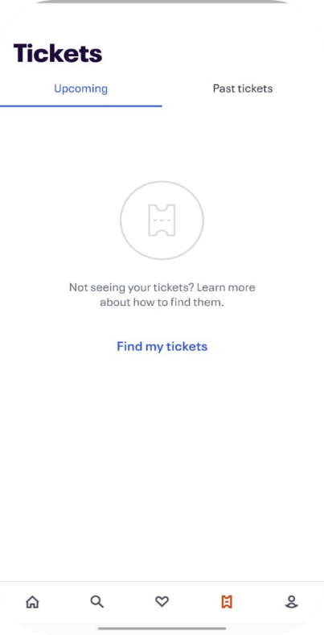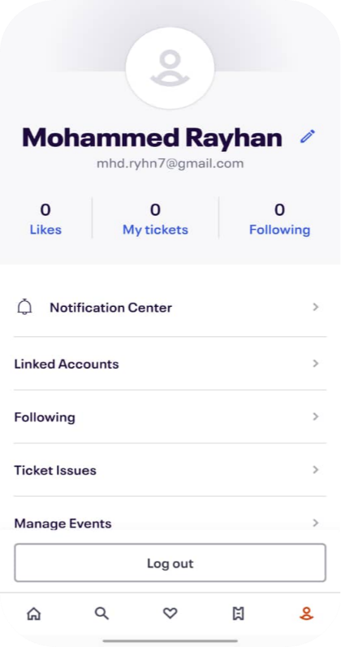

Figure 16 : Tickets Page Figure 17: Profile Page

The tickets page as shown in figure 16, shows the tickets of upcoming and previous events. The profile page shows various details regarding the user and along with various other functionalities as seen in Figure 17 and also allows the user to log out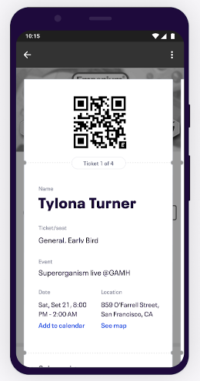

Figure 18: QR code tickets

Upon purchase, users on the eventbrite app can see tickets to their past and upcoming events on the ticket’s screen as seen in Figure . These tickets can be tapped to display a QR code (as seen in Figure 18) which can be scanned to allow entry into the event, making the process completely digital and removing the need for a physical copy.

Both apps are free to download. The Eventbrite app does not have any additional payments are users are only required to pay when purchasing tickets. The Eventbrite organizer app is free for organizers who are not charging users for tickets to their event., however if the organizer chargers users to purchase the tickets, then they are charges depending on the plan chosen by the organizer. The essentials plan which allows for one ticket type and listing on Eventbrite and partner sites charges $0.79 + 2.5% of the ticket value per ticket as a service fee [4]. The professional which offers everything in essentials along with unlimited ticket sales, detailed sales analytics, scheduled payouts and reserved seating charges $1.59 + 3.5% of the ticket value per ticket as a service fee [4]. There also exists a premium plan, whose pricing is varied and based on what the organizer wants.

The app is available for download on both Google Play Store for android devices and the AppStore for IOS devices.. It has an average rating of 4.9 stars out of 5 on the app store with 711.6 thousand user ratings and 4.6 stars out of 5 star rating [7] on Play Store with 144 thousand user rating [6] at the time of writing this report. Based on reviews, Common issues users face include ineffectivity of the event search function and search filters, online payment issues, inability to logjn after changing password

## 2.3 All Events in City

The third event planning app that will be “All Events In City” app which also has more than 500 thousands downloads on Play store. The app allows users to learn about and join upcoming events, online events, and activities in the great outdoors in their city and the surrounding area. The app also gives recommendations on events tailored to the users interests. Even without sign up the app allows users to browse events by genre, browse events by city, or view events by location, add events to the phone calendar and Sort events by date and category.

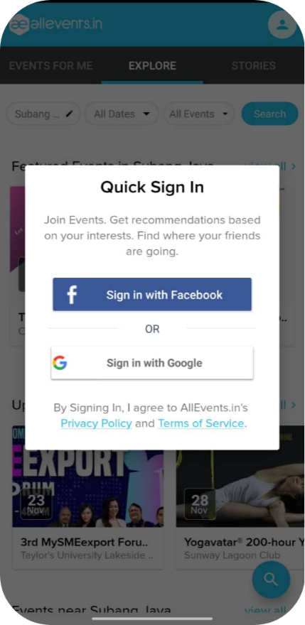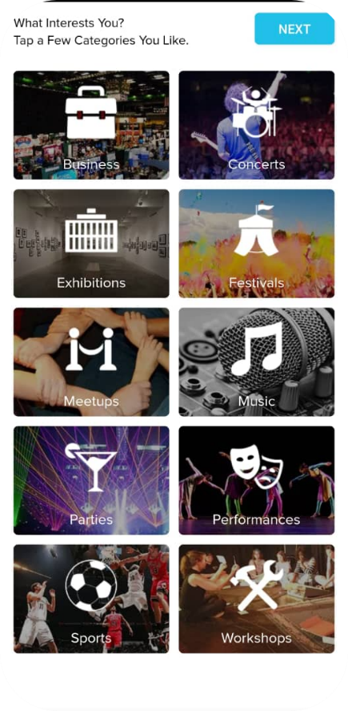

Figure 19: Sign in/up page of the application Figure 20: Category selection page after user sign up

The app allows users to sign up using either Facebook or Google. Once the user creates an account, a page that allows the users choose the category of events they are interested in pops up as seen in Figure 19. This information is used to make event suggestions that are tailored to the users liking.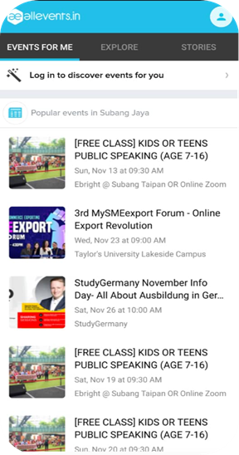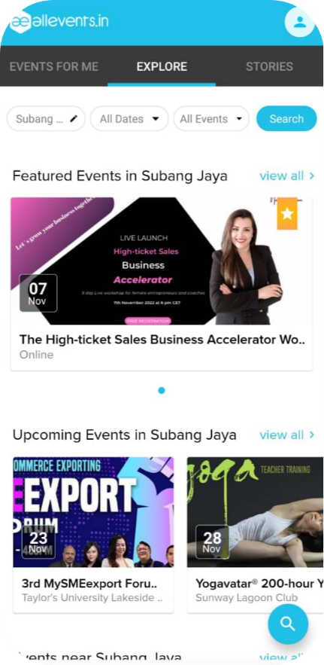

Figure 21: The ‘Events For Me’ page. Figure 22: The ‘Explore’ page.

The navigation bar which is located at the top of the screen, has three elements namely ‘Events for me’, Explore and ‘Stories’. The ‘Events for me’ page shows the user events around the users location that they can join as seen in Figure 21. The explore page of the application has a repetition of a function that the previous page has along with additional features. The page shows advertised events along with upcoming events around the user, but contrary to the previous page, this page allows users to filter results when searching for an event as seen in Figure 22

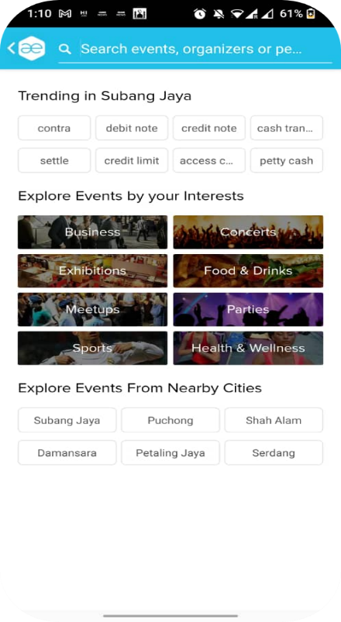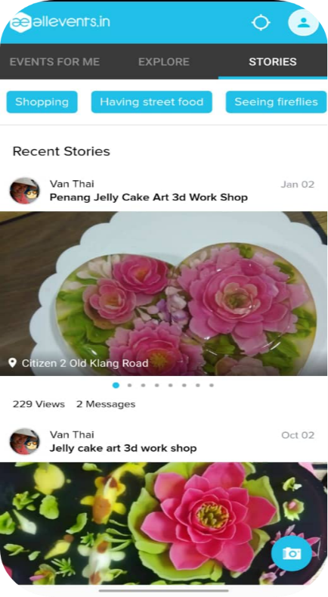

.

Figure 23: Search Page for the application Figure 24: The ‘Stories’ Page

Filters include filters for date, location and category of event as seen in Figure 23. The ‘stories’ page on as seen in Figure 24 allows users to post updates regarding events and is very similar to the ‘story’ concept on other platforms not in terms of design rather than the technical design. Users can also view stories posted by users on specific passions or categories such as shopping.

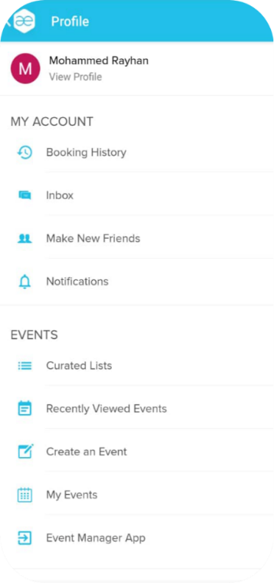

Figure 25: Profile Page

The profile page which can be accessed by clicking the top right corner of the screen contains details of the user as well as various other information such as events attends, inbox, booking history as well as option to perform functions such as creating an event, making new friends etc. It is also the page that allows the user to log out.

The app is free to download on both platforms. The app is available for download on both Google Play Store for android devices and the AppStore for IOS devices. It is developed by Amitech Business Solutions. It has an average rating of 4.6 stars out of 5 on the app store with 541 user ratings [8] and 4.2 stars out of 5 star rating on Play Store with 5,372 thousand user rating [9] at the time of writing this report. Based on reviews, Common issues users face incorrect location detection, delay or no rewards from the app after referring friends, lack of events and restricted sign up options (only allows Facebook and Google Account for sign up as seen in Figure 11).

## 2.4 Conclusion

|  |  |  |  |
| --- | --- | --- | --- |
| Application Name | Meet up | EventBrite | All Events in City |
| Number of Downloads | 10 Million + (Play Store) | 10 Million + (Play Store) | 500 Thousand + (Play Store) |
| Sign Up Methods | Facebook, Google Account and Email | Facebook, Google Account and Email | Facebook and Google Account |
| Charges for Event Organizers | Starts from $9.99 to $98.99 for monthly plans | Starts from $0.79 + 2.5% of ticket / ticket to $1.59 + 3.5% of ticket / ticket | No additional charges |
| Navbar Elements | 4 (home, explore, notifications and messages) | 5 (home, explore, favorites, tickets and profile) | 3 (Events for me, Explore and Stories) |
| Notable Features |  |  |  |
| Rating on App Store | 4.5 / 5 (166 Thousand Ratings) | 4.9 / 5 (711 thousand ratings) | 4.6 / 5 (541 ratings) |
| Rating on PlayStore | 4.5 / 5 (166 Thousand Ratings) | 4.6 / 5 (144 Thousand Ratings) | 4.2 / 5 (5372 Ratings) |
| Issues | * Email/notification spam * Disabling Notifications * Inability to cancel subscription | * Ineffectivity of the event search function search filters * online payment issues * Issues with Login | * Incorrect Location Detection * Lack of Events * Fault referral system * Restricted Sign up Options |

After comparing the three different apps, the app this project proposes will focus on implementing the positives or advantages of the apps we have compared

# 3.0 Methodology

## 3.1 Capstone

### 3.1.1 Capstone 1

| **Work Activities** | **Description** | **Deliverables** | **Predecessor/Succesor** | **Due by** |
| --- | --- | --- | --- | --- |
| 1. Generate Initial Project Plan | Create a report detailing the project's aims and goals. A rough Gantt chart of the project's timeline, a list of requirements, and a list of tasks are also included. | Initial Project plan | **Predecessor :**  Not Applicable  **Successor:**  Define Problem Statement | Week 5 |
| 2. Define Problem Statement | Think of a topic that has both broad public appeal and direct relevance to you. The next step is to do some quick investigation to confirm the existence of the highlighted issue. | Problem Statement | **Predecessor:**  Generate Initial Project Plan  **Successor:**  Define Project Objectives and Scope | Week 6 |
| 3. Define Project Objectives and Scope | The project's goals lay out the expected outcomes, and the project's scope lays out the deliverables and boundaries set up to ensure that the study and subsequent report stay on track to achieve those goals. | Project Objectives and Scope | **Predecessor:**  Define Problem Statement  **Successor:**  Perform Literature Review | Week 6 |

| 4. Perform Literature Review | Conducting in-depth reading and research of relevant academic literature. Sources and research should be connected to the project scope and aim, and all sources should be reviewed and carefully chosen. In the circumstances of this project, review and research regarding similar applications available on mobile application store is to be performed. | Literature Review | **Predecessor:**  Define Project Objectives and Scope  **Successor:**  Propose solution to the problem | Week 8 |
| --- | --- | --- | --- | --- |
| 1. Formulating a solution for the problem | Based on the examination of similar existing systems and other related work in the literature review, provide a solution to the problem highlighted. | Explain proposed solution and functions | **Predecessor:**  Perform Literature Review  **Successor:**  Produce Requirements Specifications | Week 9 |
| 6. Produce  Requirement Specifications | Specifications for the solution being provided, both functional and otherwise. | Requirment Specifications | **Predecessor:**  Propose solution to the problem  **Successor:**  Decide on tools and programming language used in the project | Week 9 |

| 7. Decide on tools and programming language used in the project | Analyze the methods used in the reviews of relevant literature to determine which methods are most suited to the project. | Tool, Techniques and Programming Language. | **Predecessor:**  Produce  Requirement Specifications  **Successor:**  Creation of User Interface Prototype | Week 10 |
| --- | --- | --- | --- | --- |
| 8. Creation of User Interface Prototype | Construct a clickable prototype of the app's user interface (UI)  on Figma and offer extensive descriptions of each UI piece. Create a flowchart of the application's user interface navigations to demonstrate how users can navigate the product. | User Interface Prototype | **Predecessor:**  Decide on tools and programming language used in the project  **Successor:**  Making Flowcharts and UML Diagrams | Week 11 |
| 9.Making Flowcharts and UML Diagrams | The features and specifications of the project will be more clearly depicted and technically outlined with the use of UML diagrams and flowcharts. | Data flow diagram, Use case diagram, Entity relationship diagram and Class diagram and | **Predecessor:**  Creation of User Interface Prototype  **Successor:**  Deciding on system architecture | **Week 13** |
| 10. Deciding on system architecture | A system architecture will be chosen to guide the structure of the project development. | System Architecture | **Predecessor:**  Making Flowcharts and UML Diagrams  **Successor:**  Creation of User Interface Prototype | **Week 13** |
| 11. Create the Gantt Chart | Make a Gantt chart to track the project's development and identify key milestones. | Grant chart | **Predecessor:**  Deciding on system architecture  **Successor:**  Not Applicable | **Week 13** |

| 3.1.2 Capstone 2 | | | | |
| --- | --- | --- | --- | --- |
| Work Activities | Description | Acceptance Criteria | Predecessor/ Succesor | Expected Duration to Complete Task |
| 1. Create a signup/login user interface for the Event Host and the Attendees/Members. | Using Android Studio, create the UI layouts for the sign-up and login pages for both event organizer and member. | The UI should be designed and developed according to the UI prototype created on figma. | **Predecessor:**  None  **Successor:**  Create and test sign up and login function for both the Event Host and the Attendees/Members | 1 day |
| 1. Create and test sign up and login function for both the Event Host and the Attendees/Members | Create the Java code for the account registration and login functionality, then integrate it into the sign up and login screens to allow users to register and/or log in. Test the account registration and login functions for functionality and troubleshoot any issues. | Both type of users are successfully able to create accounts and log in to these accounts and their details are added to the database | **Predecessor:**  Create a signup/login user interface for the Event Host and the Attendees/Members.  **Successor:**  Create a ‘Listed Events’ Page UI both for the Event Host and the Attendees/Members | 1 week |
| 1. Create a ‘Listed Events’ Page UI both for the Event Host and the Attendees/Members | Using Android Studio create the UI layouts for the ‘Listed Events Page’ (home pages) of the Event Host and the Attendees/Members . | The UI should be designed and developed according to the UI prototype created on figma. | **Predecessor:**  Create and test sign up and login function for both the Event Host and the Attendees/Members **Successor:**  Create and test the ‘Remove Event’ function (Event Organizer Side) | 1 day |
| 1. Create and test the ‘Remove Event’ function (Event Organizer Side) | Create the Java code for the edit profile function's backend and incorporate it into the finished Listed Events UI to allow users to delete events they have created. The Remove Event function should be tested for functionality, and any errors should be investigated. | The event deleted should not show up on the Event organizers ‘Listed Events’ page | **Predecessor:**  Create a ‘Listed Events’ Page UI both for the Event Host and the Attendees/Members  **Successor:**  Create a ‘Create Event’ Page UI (Event Organizer Side) | 3 days |
| 1. Create a ‘Create Event’ Page UI (Event Organizer Side) | Using Android Studio create the UI layouts for the ‘ Create Event page’ for the Event Organizer. | The UI should be designed and developed according to the UI prototype created on figma. | **Predecessor:**  Create and test the ‘Remove Event’ function (Event Organizer Side)  **Successor:**  Create and test the ‘Create Event’ function (Event Organizer Side) | 1 day |
| 1. Create and test the ‘Create Event’ function (Event Organizer Side) | Create the Java code for the ‘Create Event’ function's backend and incorporate it into the finished ‘Create Event’ Page UI to allow users to create new events. The create event function should be tested for functionality, and any errors should be investigated. | The event created shows up on the ‘Listed Events’ for Organizer and shows up on the ‘Join Events’ page of member | **Predecessor:**  Create a ‘Create Event’ Page UI (Event Organizer Side)  **Successor:**  Create and test the ‘View Reviews’ function (Event Organizer Side) | 1 week |
| 1. Create a ‘Review’ Page UI (Event Organizer) | Using Android Studio create the UI layouts for the ‘Review’ page for the Event Organizer. | The UI should be designed and developed according to the UI prototype created on figma. | **Predecessor:**  Create and test the ‘Create Event’ function (Event Organizer Side)  **Successor:**  Create and test the ‘View Reviews’ function (Event Organizer Side) | 1 day |
| 1. Create and test the ‘View Reviews’ function (Event Organizer Side) | Create the Java code for the ‘View Reviews’ function's backend and incorporate it into the finished 's UI to allow organizers to see reviews on their event. The ‘View Reviews’ function should be tested for functionality, and any errors should be investigated. | The organizers are able to see the reviews from different members regarding different events along with rating | **Predecessor:**  Create and test the ‘Create Event’ function (Event Organizer Side)  **Successor:**  Create a ‘Join Event’ Page UI (Member Side) | 3 days |
| 1. Create a ‘Join Event’ Page UI (Member Side) | Using Android Studio create the UI layouts for the ‘ Create Event’ page for the Event Organizer. | The UI should be designed and developed according to the UI prototype created on figma. | **Predecessor:**  Create and test the ‘View Reviews’ function (Event Organizer Side)  **Successor:**  Create and test the ‘Join Event’ function (Member Side) | 1 day |
| 1. Create and test the ‘Join Event’ function (Member Side) | Create the Java code for the edit profile function's backend and incorporate it into the finished Join Event's UI to allow users to join events. The join event function should be tested for functionality, and any errors should be investigated. | The event joined shows up on the members ‘Listed Events’ page once a member joins and it adds to the member counter for organizer | **Predecessor:**  Create a ‘Join Event’ Page UI (Member Side).  **Successor:**  Create and test the ‘Filter Event’ function (Member Side). | 1 week |
| 1. Create and test the ‘Filter Event’ function (Member Side) | Create the Java code for the edit profile function's backend and incorporate it into the finished ‘Join Event’s’ UI to allow users to filter events on specific criterias. The filter event function should be tested for functionality, and any errors should be investigated. | It successfully filters events for members based on the different filters available. | **Predecessor:**  Create and test the ‘Join Event’ function (Member Side)  **Successor:**  Create and test the ‘View Ticket’ function (Member Side) | 3 days |
| 1. Create and test the ‘View Ticket’ function (Member Side) | Create the Java code for the edit profile function's backend and incorporate it into the finished ‘Listed Events Page’ to view the tickets they have purchased. The view ticket function should be tested for functionality, and any errors should be investigated. | Members are able to see their virtual ticket on their ‘Listed Events Page’. | **Predecessor:**  Create and test the ‘Filter Event’ function (Member Side)  **Successor:**  Create and test the ‘Make Review’ function (Member Side) | 3 days |
| 1. Create and test the ‘Make Review’ function (Member Side) | Create the Java code for the edit profile function's backend and incorporate it into the finished Review Page's UI to allow users to create review’s for events they joined. The make review function should be tested for functionality, and any errors should be investigated. | Member can successfully review an event he attends and the review shows up on the ‘Reviews Page’ of respective organizer. | **Predecessor:**  Create a ‘Review’ Page UI (Member Side)  **Successor:**  Create a profile page user interface for the Event Host and the Attendees/Members. | 3 days |
| 1. Create a profile page UI for the Event Host and the Attendees/Members. | In Android Studio, create the UI layouts for the profile page on both the customer and merchant side applications. | The UI should be designed and developed according to the UI prototype created on figma. | **Predecessor:**  Create and test the ‘Make Review’ function (Member Side)  **Successor:**  Create and test the ‘Edit User Profile’ function for both Event Host and the Attendees/Members | 1 day |
| 1. Create and test the ‘Edit User Profile’ function for both Event Host and the Attendees/Members | Create the Java code for the edit profile function's backend and incorporate it into the finished profile page's UI to allow users to modify their profile data. The edit profile function should be tested for functionality, and any errors should be investigated. | Both type of users are allowed to edit details of profile that are only allowed to be edited and the information is updated in the database | **Predecessor:**  Create a profile page user interface for the Event Host and the Attendees/Members.  **Successor:**  Testing | 3 days |
| 1. Testing | Test the entire application using all of its functions to find potential faults and defects. Create test plan so that a step by step testing of each function can be done. | Testing the application in a real-world situations, as well as assessing the overall application with all of its functions and identifying potential issues and bugs. | **Predecessor:**  Create and test the ‘Edit User Profile’ function for both Event Host and the Attendees/Members  **Successor:**  Producing final report | 2 weeks |
| 14. User Acceptance Testing | Collect a group of individuals to test the application and fill up a questionnaire to gauge the performance of the app. | Ensuring the users use the app before filling up the questionnaire and a minimum of 10 people. | **Predecessor:**  User Acceptance Testing  **Successor:**  None | 1 week |
| 15. Producing final report | Add all of the above details to a concluding report. | Final Report | **Predecessor:**  User Acceptance Testing  **Successor:**  None | 6 weeks |

## 3.2 Risk Analysis

| **Work Activity** | **Risk Involved** |
| --- | --- |
| 1.Generate Initial Project Plan | Creating an unrealistic project plan and unreachable deadlines which may lead to late submission or a topic change. |
| 2. Define Problem Statement | No Risk |
| 3. Define Project Objectives and Scope | Critical project scopes may not be covered or the goals and scope defined may be impossible to accomplish. |
| 4. Perform Literature Review | Not conducting a thorough enough and reliable search for relevant works, journal articles, and other sources. and neglect to choose pertinent resources. |
| 5.Formulating a solution for the problem | No Risk |
| 6.Produce Requirement Specifications | Requirements do not align satisfy the needs of the solution and lack of so could lead to creating a product that does not serve its purpose |
| 7.Decide on tools and programming language used | Selection of unsuitable or fitting tools and programming language to achieve the technical aspects of this project. |
| 8. Creation of User Interface Prototype | Creating a unappealing user interface that does not allow the technical functions of the app to be used |
| 9. Making Flowcharts and UML Diagrams | Producing a data flow that is an inaccurate representation of the actual flow of data. Incorrect ERD relations in the ERD diagram. Use case |
| 10. Deciding on system architecture | Low risk |
| 11. Create the Gantt Chart | No Risk |
| 12.Create a signup/login user interface for the Event Host and the Attendees/Members. | No risk Involved if the User Interface Prototype has been designed appropriately. |
| 13.Create and test sign up and login function for both the Event Host and the Attendees/Members | Creating a faulty function that does not serve it purpose. In this scenario, a function that doesn’t allow users to successfully sign up/login possibly due to faulty storage of user information |
| 14. Create a ‘Listed Events’ Page UI both for the Event Host and the Attendees/Members | No risk Involved if the User Interface Prototype has been designed appropriately. |
| 15. Create and test the ‘Remove Event’ function (Event Organizer Side) | Creating a faulty function that does not serve it purpose. In this scenario, the event is not removed even after the event organizer has clicked the icon to delete the event. |
| 16. Create a ‘Create Event’ Page UI (Event Organizer Side) | No risk Involved if the User Interface Prototype has been designed appropriately. |
| 17. Create and test the ‘Create Event’ function (Event Organizer Side) | Creating a faulty function that does not serve it purpose. In this scenario, the event created does not show up on either the event organizer or member sides. |
| 18. Create and test the ‘View Reviews’ function (Event Organizer Side) | Creating a faulty function that does not serve it purpose. In this scenario, event organizers are unable to see the reviews from members. |
| 19. Create a ‘Join Event’ Page UI (Member Side) | No risk Involved if the User Interface Prototype has been designed appropriately. |
| 20. Create and test the ‘Join Event’ function (Member Side) | Creating a faulty function that does not serve it purpose. In this scenario, users are unable to join the event, which could possibly occur due to faulty code. |
| 21. Create and test the ‘Filter Event’ function (Member Side) | Creating a faulty function that does not serve it purpose. In this scenario, the filter does no/incomplete/faulty filtering of events and could occur possibly due to error in code. |
| 22. Create and test the ‘View Ticket’ function (Member Side) | Creating a faulty function that does not serve it purpose. In this scenario, users are unable to see tickets / incorrect tickets for events they joined and could occur possibly due to improper retrieval of information from the database |
| 23. Create and test the ‘Make Review’ function (Member Side) | Creating a faulty function that does not serve it purpose. In this scenario, users are unable to post their reviews for events they have joined. |
| 24. Create a profile page UI for the Event Host and the Attendees/Members. | No risk Involved if the User Interface Prototype has been designed appropriately. |
| 25. Create and test the ‘Edit User Profile’ function for both Event Host and the Attendees/Members | Creating a faulty function that does not serve it purpose. In this scenario, users cannot change their information which is editable and could occur possibly due to improper updating of database. |
| 26. Testing | Not using appropriate tests and not testing functions to their full potential. Not every bug or flaw is discovered. |
| 27 . Producing final report | Incomplete and Low quality final Report |

## 3.3 Gantt Chart

| **Tasks** | Weeks | | | | | | | | | | | | | | | | | | | | | | | | | | | |
| --- | --- | --- | --- | --- | --- | --- | --- | --- | --- | --- | --- | --- | --- | --- | --- | --- | --- | --- | --- | --- | --- | --- | --- | --- | --- | --- | --- | --- |
| Capstone 1 | | | | | | | | | | | | | | Capstone 2 | | | | | | | | | | | | | |
| 1 | 2 | 3 | 4 | 5 | 6 | 7 | 8 | 9 | 10 | 11 | 12 | 13 | 14 | 15 | 16 | 17 | 18 | 19 | 20 | 21 | 22 | 23 | 24 | 25 | 26 | 27 | 28 |
| 1.Generate Initial Plam |  |  |  |  |  |  |  |  |  |  |  |  |  |  |  |  |  |  |  |  |  |  |  |  |  |  |  |  |
| 2. Define Problem Statement |  |  |  |  |  |  |  |  |  |  |  |  |  |  |  |  |  |  |  |  |  |  |  |  |  |  |  |  |
|  |  |  |  |  |  |  |  |  |  |  |  |  |  |  |  |  |  |  |  |  |  |  |  |  |  |  |  |  |
| 3. Define Project Objectives and Scope |  |  |  |  |  |  |  |  |  |  |  |  |  |  |  |  |  |  |  |  |  |  |  |  |  |  |  |  |
| 4. Perform Literature Review |  |  |  |  |  |  |  |  |  |  |  |  |  |  |  |  |  |  |  |  |  |  |  |  |  |  |  |  |
| 5.Formulating a solution for the problem |  |  |  |  |  |  |  |  |  |  |  |  |  |  |  |  |  |  |  |  |  |  |  |  |  |  |  |  |
| 6.Produce Requirement Specifications |  |  |  |  |  |  |  |  |  |  |  |  |  |  |  |  |  |  |  |  |  |  |  |  |  |  |  |  |
| 7.Decide on tools and programming language used |  |  |  |  |  |  |  |  |  |  |  |  |  |  |  |  |  |  |  |  |  |  |  |  |  |  |  |  |
| 8. Creation of User Interface Prototype |  |  |  |  |  |  |  |  |  |  |  |  |  |  |  |  |  |  |  |  |  |  |  |  |  |  |  |  |
| 9. Making Flowcharts and UML Diagrams |  |  |  |  |  |  |  |  |  |  |  |  |  |  |  |  |  |  |  |  |  |  |  |  |  |  |  |  |
| 10. Deciding on system architecture |  |  |  |  |  |  |  |  |  |  |  |  |  |  |  |  |  |  |  |  |  |  |  |  |  |  |  |  |
| 11. Create the Gantt Chart |  |  |  |  |  |  |  |  |  |  |  |  |  |  |  |  |  |  |  |  |  |  |  |  |  |  |  |  |
| 12.Create a signup/login user interface for the Event Host and the Attendees/Members. |  |  |  |  |  |  |  |  |  |  |  |  |  |  |  |  |  |  |  |  |  |  |  |  |  |  |  |  |
| 13.Create and test sign up and login function for both the Event Host and the Attendees/Members |  |  |  |  |  |  |  |  |  |  |  |  |  |  |  |  |  |  |  |  |  |  |  |  |  |  |  |  |
| 14. Create a ‘Listed Events’ Page UI both for the Event Host and the Attendees/Members |  |  |  |  |  |  |  |  |  |  |  |  |  |  |  |  |  |  |  |  |  |  |  |  |  |  |  |  |
| 15. Create and test the ‘Remove Event’ function (Event Organizer Side) |  |  |  |  |  |  |  |  |  |  |  |  |  |  |  |  |  |  |  |  |  |  |  |  |  |  |  |  |
| 16. Create a ‘Create Event’ Page UI (Event Organizer Side) |  |  |  |  |  |  |  |  |  |  |  |  |  |  |  |  |  |  |  |  |  |  |  |  |  |  |  |  |
| 17. Create and test the ‘Create Event’ function (Event Organizer Side) |  |  |  |  |  |  |  |  |  |  |  |  |  |  |  |  |  |  |  |  |  |  |  |  |  |  |  |  |
| 18. Create and test the ‘View Reviews’ function (Event Organizer Side) |  |  |  |  |  |  |  |  |  |  |  |  |  |  |  |  |  |  |  |  |  |  |  |  |  |  |  |  |
| 19. Create a ‘Join Event’ Page UI (Member Side) |  |  |  |  |  |  |  |  |  |  |  |  |  |  |  |  |  |  |  |  |  |  |  |  |  |  |  |  |
| 20. Create and test the ‘Join Event’ function (Member Side) |  |  |  |  |  |  |  |  |  |  |  |  |  |  |  |  |  |  |  |  |  |  |  |  |  |  |  |  |
| 21. Create and test the ‘Filter Event’ function (Member Side) |  |  |  |  |  |  |  |  |  |  |  |  |  |  |  |  |  |  |  |  |  |  |  |  |  |  |  |  |
| 22. Create and test the ‘View Ticket’ function (Member Side) |  |  |  |  |  |  |  |  |  |  |  |  |  |  |  |  |  |  |  |  |  |  |  |  |  |  |  |  |
| 23. Create and test the ‘Make Review’ function (Member Side) | . |  |  |  |  |  |  |  |  |  |  |  |  |  |  |  |  |  |  |  |  |  |  |  |  |  |  |  |
| 24. Create a profile page UI for the Event Host and the Attendees/Members. |  |  |  |  |  |  |  |  |  |  |  |  |  |  |  |  |  |  |  |  |  |  |  |  |  |  |  |  |
| 25. Create and test the ‘Edit User Profile’ function for both Event Host and the Attendees/Members |  |  |  |  |  |  |  |  |  |  |  |  |  |  |  |  |  |  |  |  |  |  |  |  |  |  |  |  |
| 26. Testing |  |  |  |  |  |  |  |  |  |  |  |  |  |  |  |  |  |  |  |  |  |  |  |  |  |  |  |  |
| 27 . Producing final report |  |  |  |  |  |  |  |  |  |  |  |  |  |  |  |  |  |  |  |  |  |  |  |  |  |  |  |  |

# 4.0 Methodology

Various technical aspects of the project are covered here, such as specifications for the system, the technologies involved, the layout of the user interface, and the models and diagrams that will be used.

## 4.1 System Requirements

There will be two categories of users for this application (Users that join events and Organizers). Each user group's functionalities will be distinct and appropriate to their own aims. The suggested application's capabilities include:

The two types of users that can use this app are the users that will join the events and organizers. There will be functionalities accessible to both type of users and functionalities unique to the two type of users.

Both Type of Users (Organizers/Event Joiner)

1. Sign up it Log in to account

New users of this application can register a new account either as a normal user or an organizer, however existing users can log in with their email address and password.

1. Edit User Information

Registered users must be able edit their information such as name, email ID, , password. However, they will not be allowed to change gender and age.

1. Logout

Users should be able to logout from their account.

Organizers

1. Create and Delete New Events

Organizers should be able to create new events that users can join and delete events they have created.

2. View user ratings and reviews

Organizers should be able to view reviews and rating from users

Members

1. Join Events and View Ticket

These Users should be able to join the different events available on the app

1. Rate/Review an Event

These users should be able to rate and review events which they have attended

1. View Previous and Existing events they have joined

These users should be able to see their active and past events

## 4.2 Related Tools and Technologies

A programming language, integrated development environment (IDE), structured query language and a prototyping software will be used to develop this mobile application.

#### 4.2.1 Back - End (Java)

To build the suggested app's backend, we'll be using Java. The logic and functionality of the Android application will be specified using the programming language Java. In addition, Java will be utilized to control the data flow from the user interface to the server and database. Java is a widely used language for creating mobile apps. Also, Java is an open-source language that provides access to a wide variety of libraries and allows for considerable leeway when designing applications.

#### *4.2.2 Front - End (Android Studio)*

Android Studio, the official IDE for Google's Android OS and Android Native application development, is used to develop the application. Android Studio was chosen for a variety of reasons. First, Android Studio includes an Android emulator that can mimic as an Android device for many platforms. It also allows users to run and directly test the applications on their PCs. In addition, Android Studio also provides the Gradle build system, which converts app resources and source code into Android Packages (APKs) that can run on Android devices and Android emulators. Finally, Android Studio provides tools for error checking that search for flaws and bugs in the code to help developers enhance the performance and usability of the code.

#### *4.2.3 Database (Firebase)*

For this task, a database is needed to keep track of data like users and organizer data. For this reason, Firebase has been chosen as the database management system. Firebases's inexpensive price, scalability on demand, good performance, and adaptability as an open source solution make it the ideal choice for this project.

#### *4.2.4 Figma*

To design the User Interface and storyboard of the application, Figma will be used. Figma is a web-based interface design and graphics editing application. Figma has a free plan that allows you to create and store three active projects at once. It is sufficient for learning, experimenting, and working on smaller projects.

## 

## 4.3 User Interface Prototype

Figma is used to design the user interface prototype of this application. Each page will have a short description explaining what the different elements shown on the page’s prototype.

#### 1. Main Page (First Page)

The figure below shows the main page/first page of the application. On this page, users just have to click the “Let’s Begin” Button.

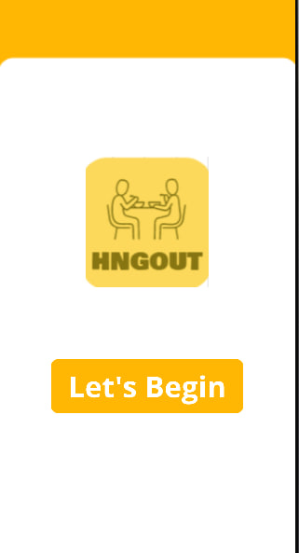

Figure 26 : Main Page of Application

#### 2.. Log in or Sign Up Page

Here, the user can choose to Log in or Signup.

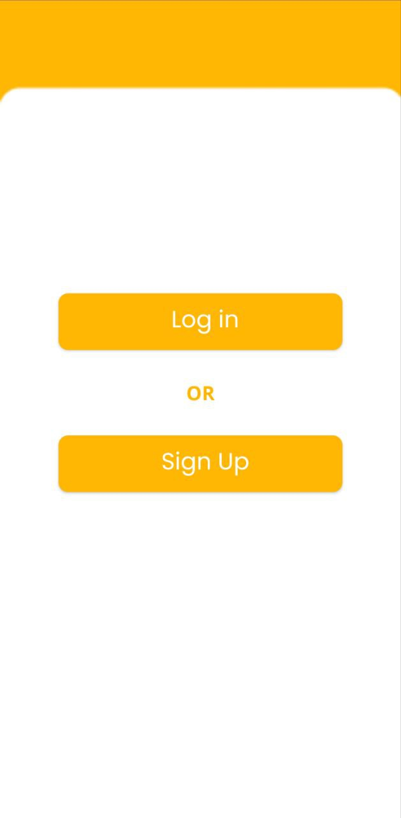

Figure 27 : Main Page of Application

#### 

#### 

#### 3. Sign Up Type Page

If the user chooses to sign up, he/she is given the option to either sign up as Event Organizer or a Regular Member. Organizer accounts can make events whereas the Member accounts can join events.

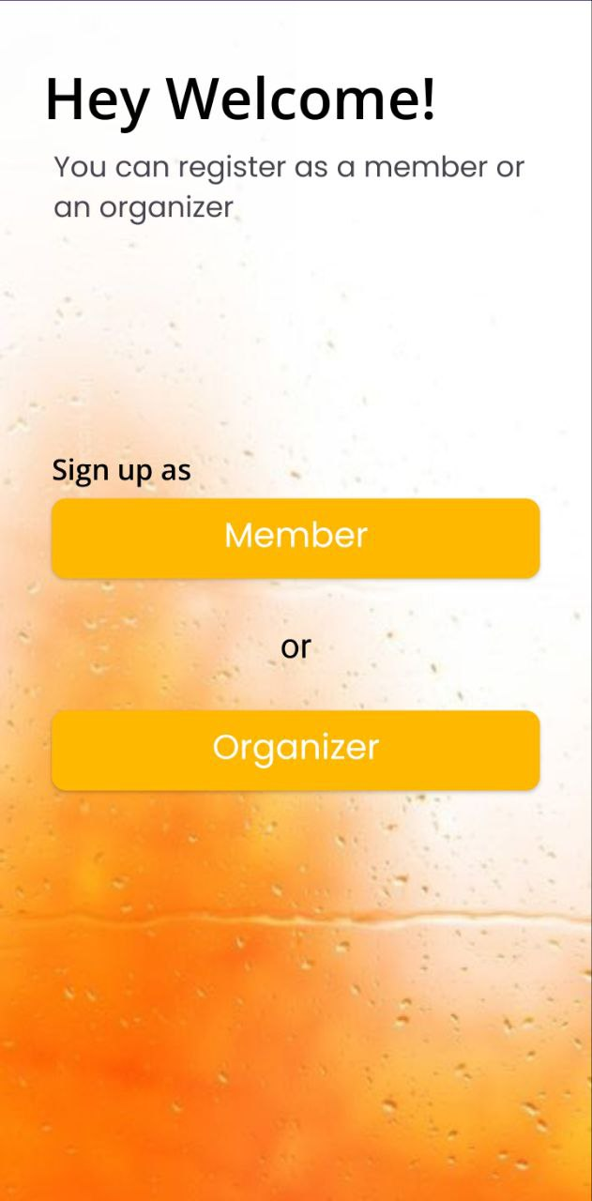

Figure 28: Sign Up Type Page of Application

#### 4. Sign Up Page

After deciding whether they want to register as an Event Organizer or a Member, users will be prompted to fill out their information in the manner as shown in Figure 29 and Figure 30. The users then need to read and accept the terms and conditions before they press the sign up button, which confirms the sign creation.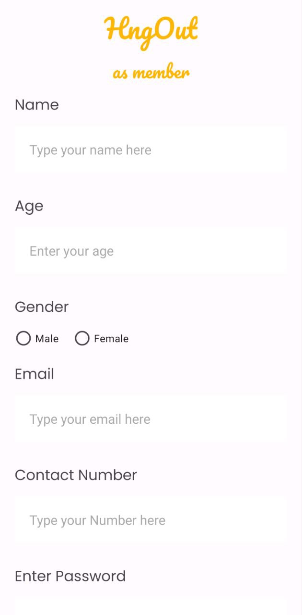

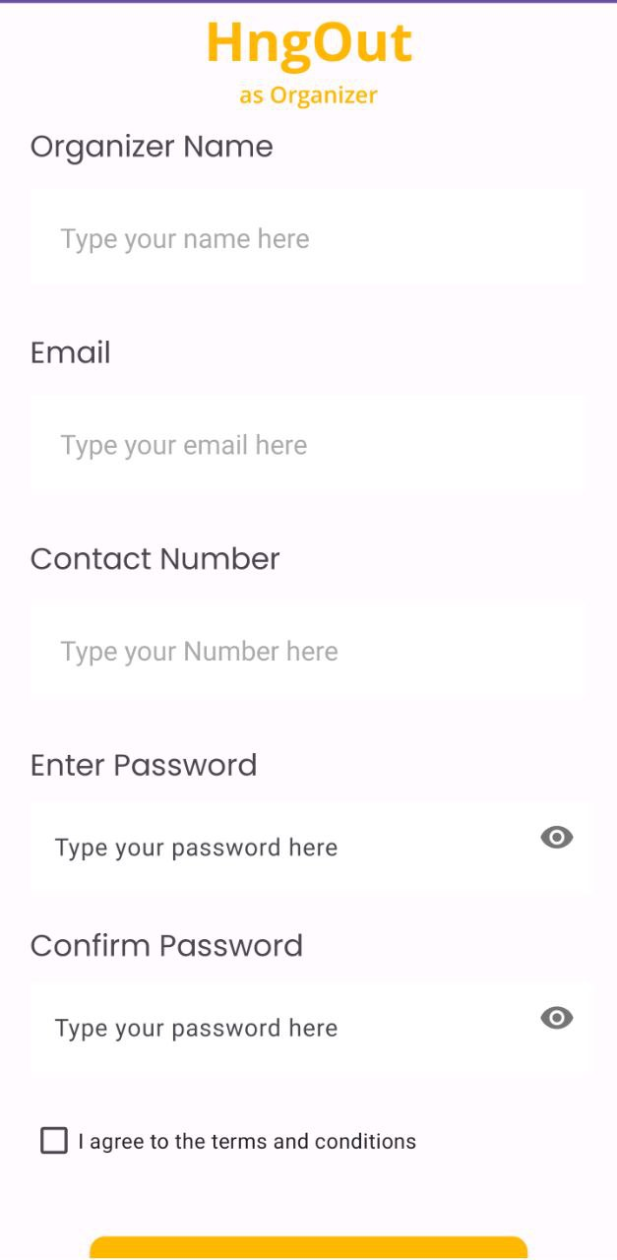

Figure 29 : Sign Up Page for Member Figure 30 : Sign Up Page for Organizer

#### 5. Set location page

Upon registration, members will be prompted to specify their location, as seen in Figure 31. Members are required to set the location around which they are searching for events. Users can either search for their location in the search box or opt to have their current location set automatically based on the location of their mobile device.

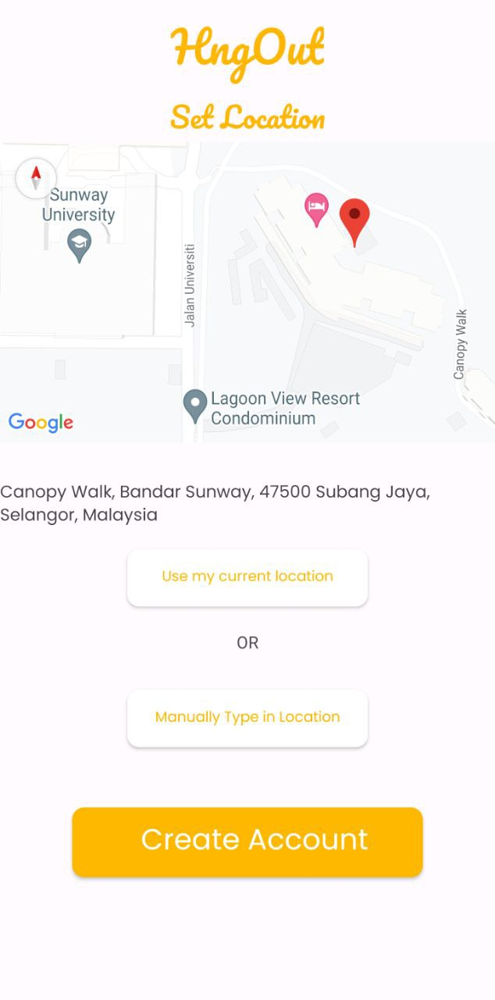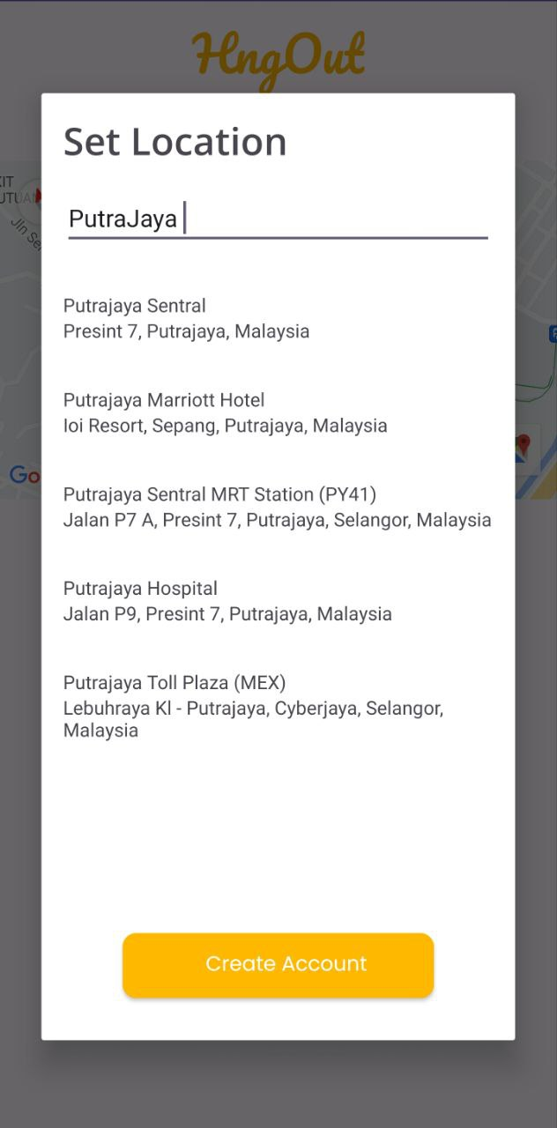

Figure 31 : Set Location Page of Application

#### 6. Login page

Once users have signed up for their accounts, they can then login. As seen in Figure 32, the users have to choose what type of account they want to login to before they login.

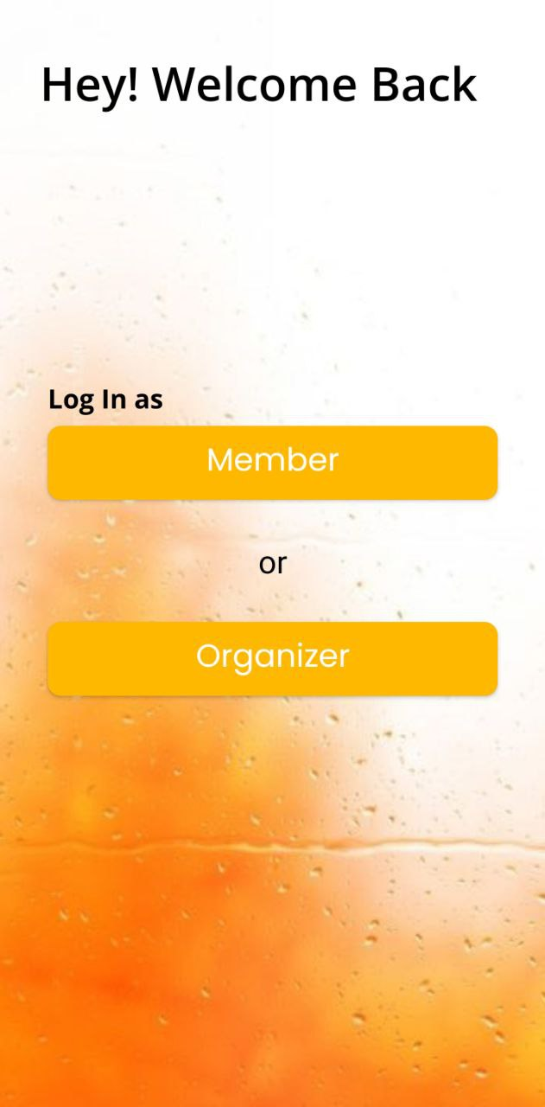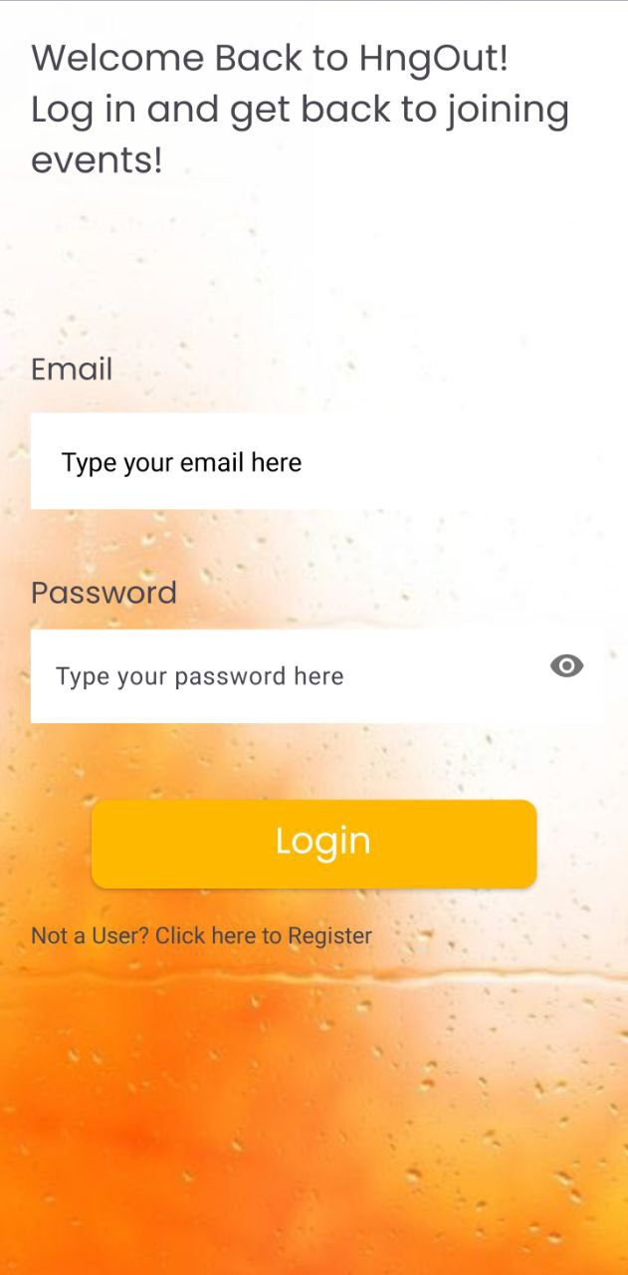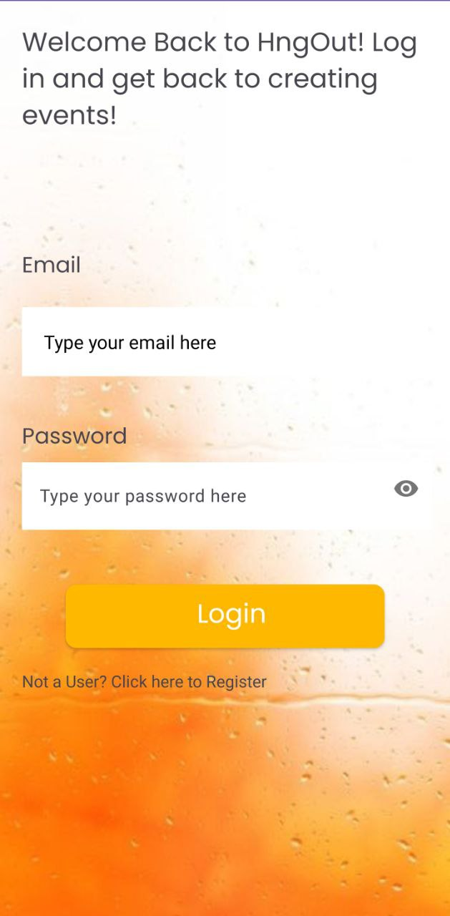

Figure 32 : Login Pages of Application

#### 7. Create Event Page (Event Organizer)

Organizers can use this page to create new events as seen in Figure 33. Organizers are recommended to add an event banner to give a visual of the event. They are also required to fill event information such as Event Name, Location, Time, Maximum Members, Category etc.

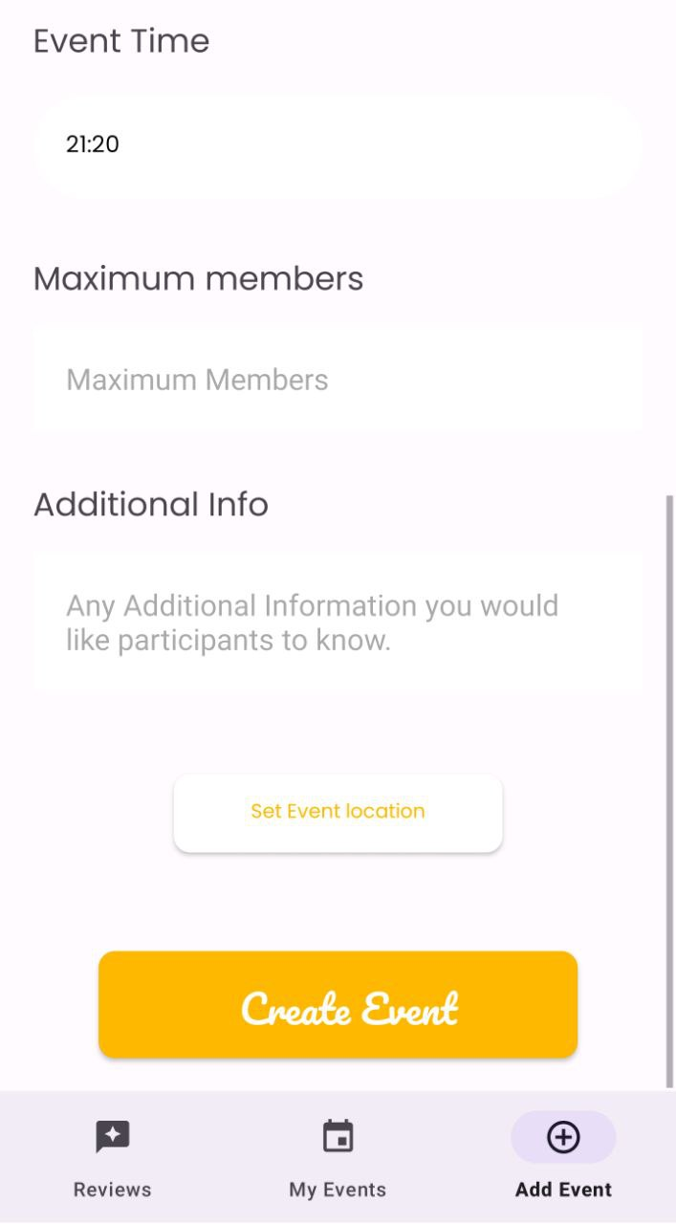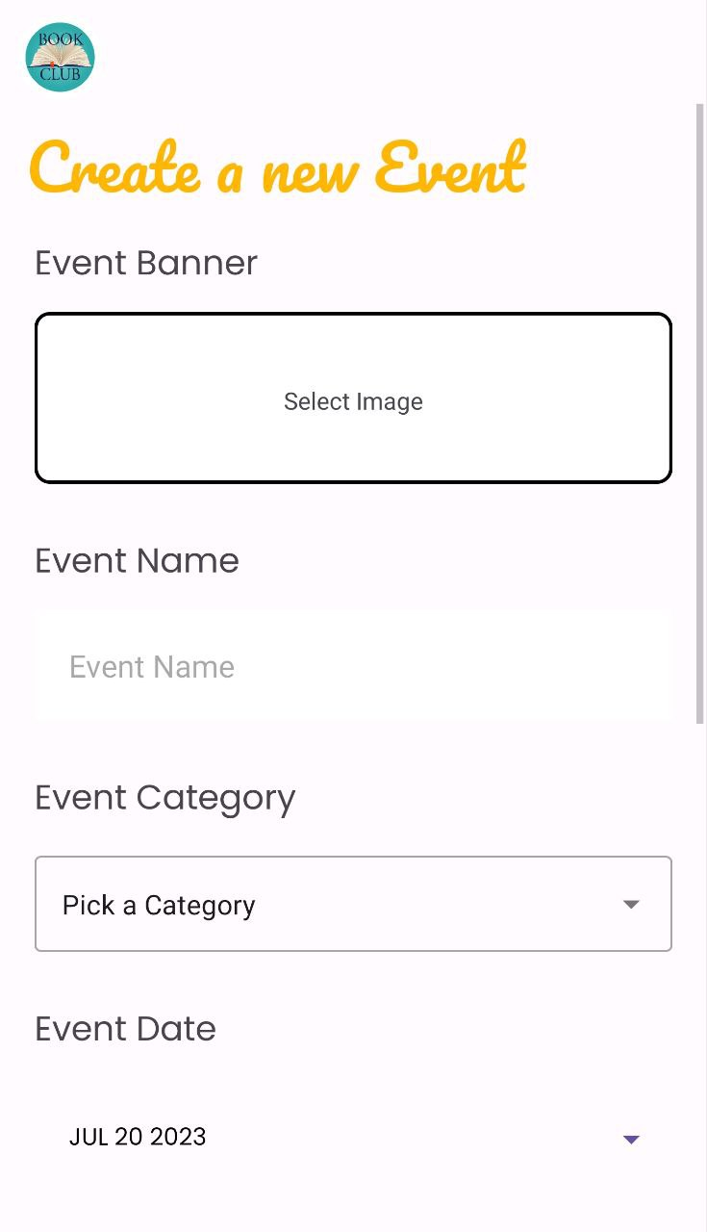

Figure 33 : Create Event Page of Application

#### 8. Set Event Location.

This page allows the event organizers to set the events location

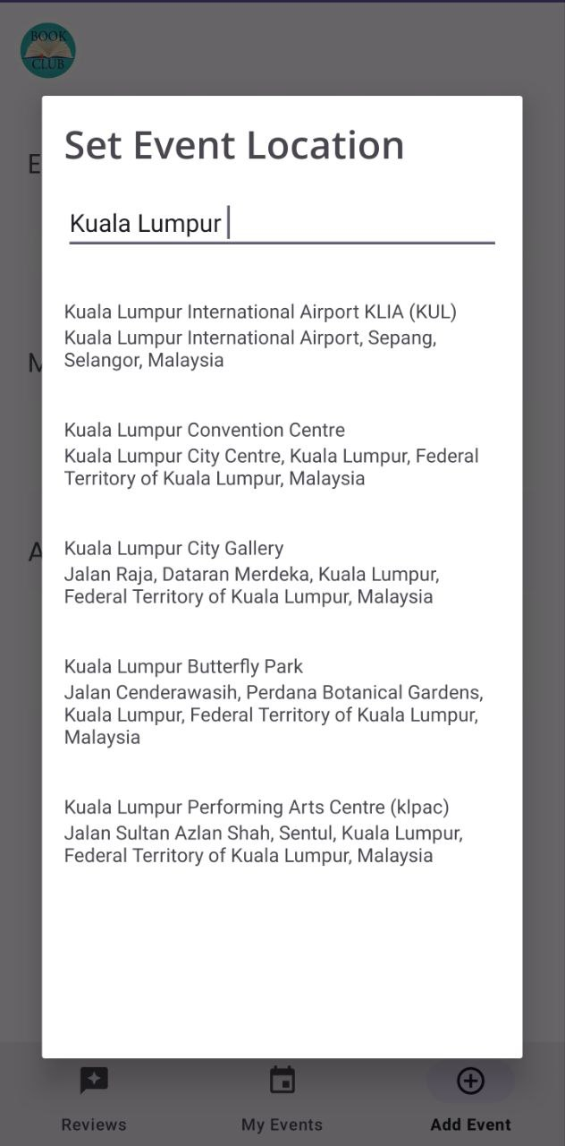

Figure 34 : Set Event Location Page

#### 9. My Events Page (Event Organizer)

This page shows the upcoming and previous events the user (event organizer) has/have created. It also shows the current number of members (for upcoming events) and number of members (for previous events). This is the first page that the Event Organizer users see when they log into their accounts.

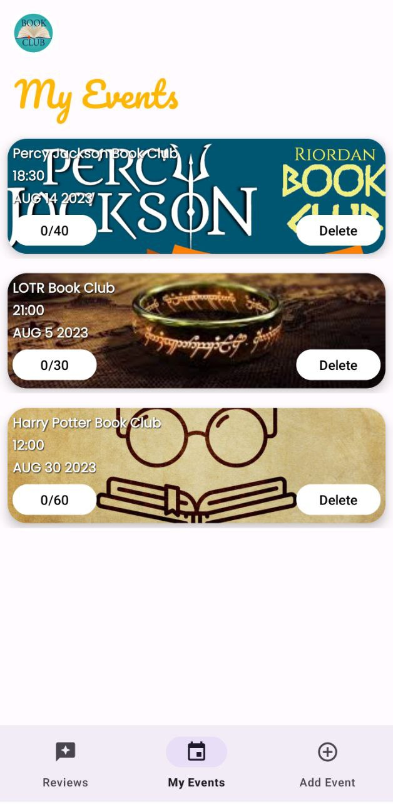

Figure 35 : My Events Page of Application

#### 10. Event Members Pop up

The Event Organizer can click the event to see the event member that have signed up, as seen in Figure 36.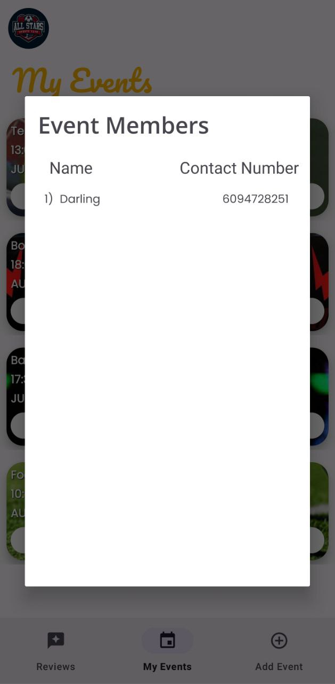

#### 

Figure 36 : Event Member Pop up

#### 

#### 

#### 

#### 

#### 

#### 

#### 

#### 

#### 

#### 

#### 11. Review page (Event Organizer)

This page shows all reviews from members who have joined events previously along with star rating out of 5 as seen in Figure 37. It also shows a brief writing from the member regarding the event.

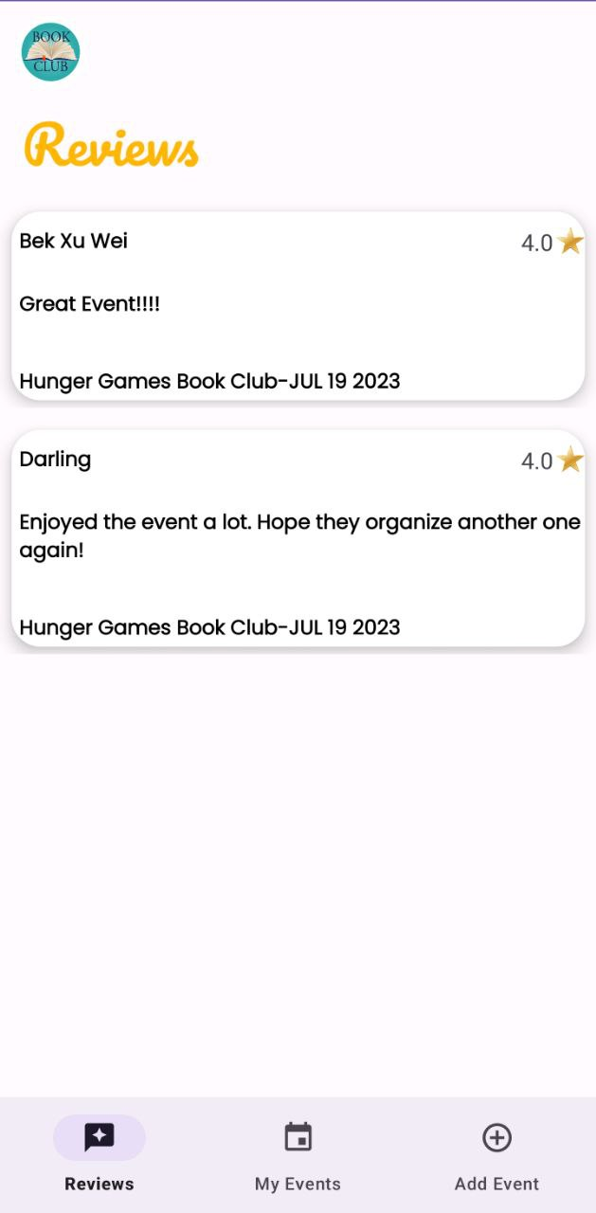

Figure 37 : Review Page (Event Organizer) for the application

#### 12. Home Page (Members)

This page shows the members featured events around the member’s locations seen in Figure 38 (it will link them to the Event search page. This is the first page that users see when they login.

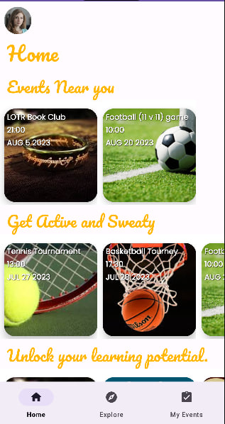

Figure 38 : Home Page (Members) for the application

#### 13. Explore Page (Members)

This page shows the members all events available as seen in Figure 39. If the user is interested he/she can join the event by pressing the event which will popup a dialog box

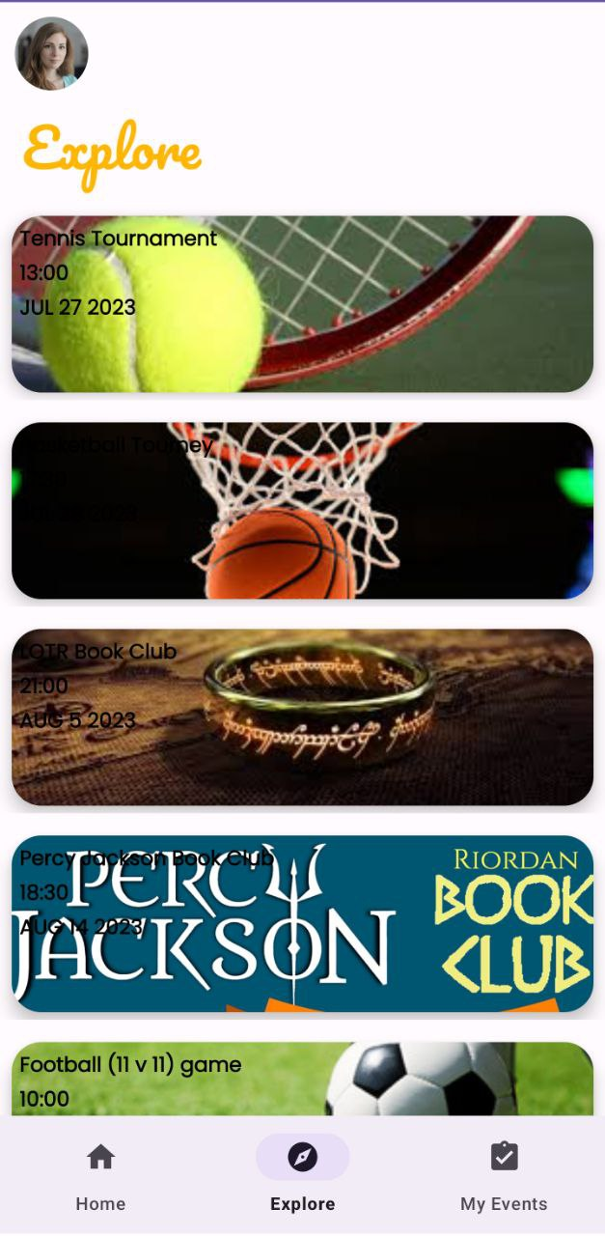

Figure 39 : Explore Event Page for the application

#### 14. Event Information Page (Member)

If the user (member) click on an event to view extra information regarding the event. Once they click the event an event description with a more detailed description of the event can be viewed. This page also allows users to join the event by pressing the button at the bottom of the screen.

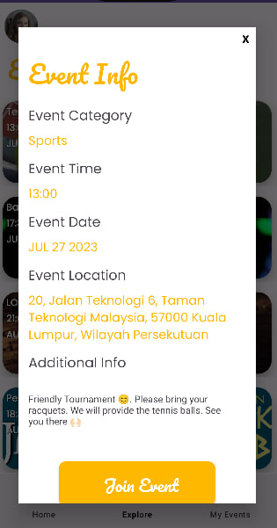

Figure 40 : Event Information Page (Member) for the application

#### 15. “My Events Page” (Member)

This page shows the upcoming and previous events the user (Members) joined as seen in Figure 41. The page also is a pathway for users to make reviews on events they have previously attended. It also allows users to see their tickets for events they have joined

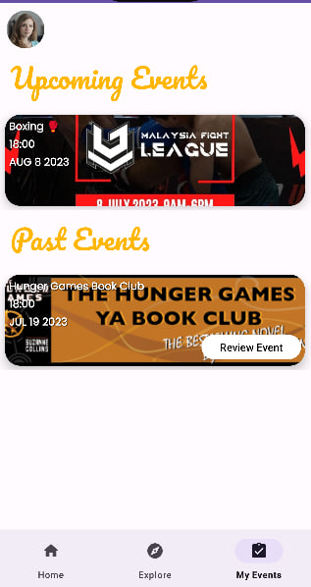

Figure 41 : “My Events Page”for Application

#### 16. View Ticket Page Member

The ticket window pops up for the user once they press the ‘View Ticket’ icon on the upcoming event icon as seen in Figure 42. This will pop up a ticket with details of the event.

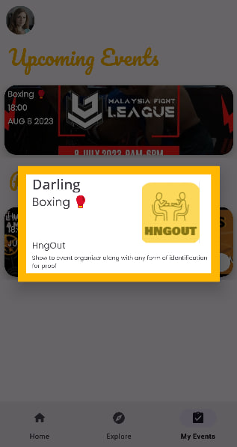

Figure 42 : View Ticket Page of the Application

#### 17. Review Page (Member)

This page allows user to write a review regarding an event they attended as well as a rating out of 5 stars as seen in Figure 43.

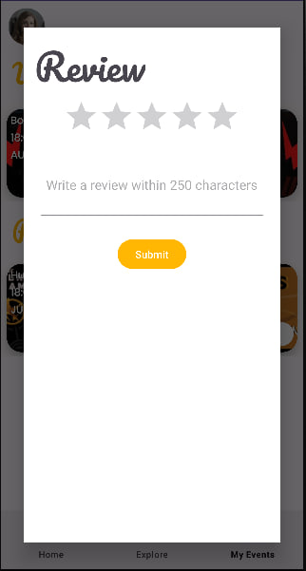

Figure 43 : Review Page (Member) for the application

#### 18. Profile page

Figure 44 and 45 depicts both the customer and member profile pages.

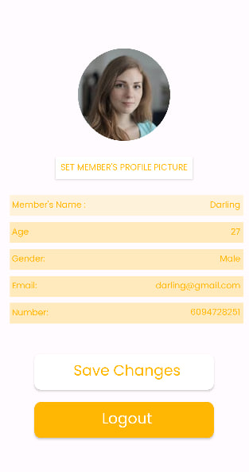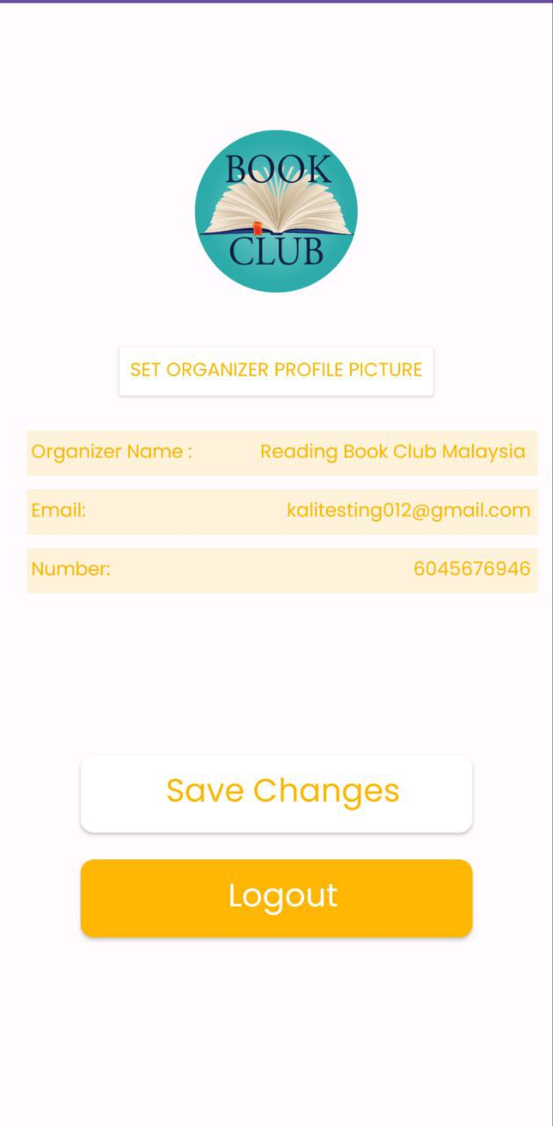

Figure 44 : Organizer Profile Page Figure 45 : Member Profile Page

### 

## 4.4 System Architecture

The system architecture that will be implemented in this project is the Model-View-Controller (MVC) architecture. MVC is the most commonly used framework for software development. The MVC pattern architecture is a three-layered architecture namely Model, View and Controller. It distinguishes application characteristics. Its Controller layer is concerned with user input logic, the Model Layer with business logic, and the view layer with the implementation of user interface logic [11] .

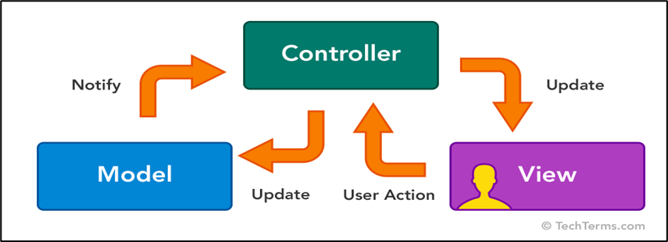

Figure 44: A representation of how the MVC architecture works

The model in Figure 44 represents how MVC architecture works. The logic of data domains is implemented using model layer. These classes are utilised to access, add, or modify data in the database connected to our application. The user interface of our application is put together with the help of views. Users are able to interact with our application by utilizing that interface. In order to process user input, controller classes are employed. In response to user input, controller classes take the appropriate action. These classes collaborate with model classes to determine the most relevant view to present to the user.

## 4.5 Model Diagrams

### 4.5.1 Data Flow Diagram

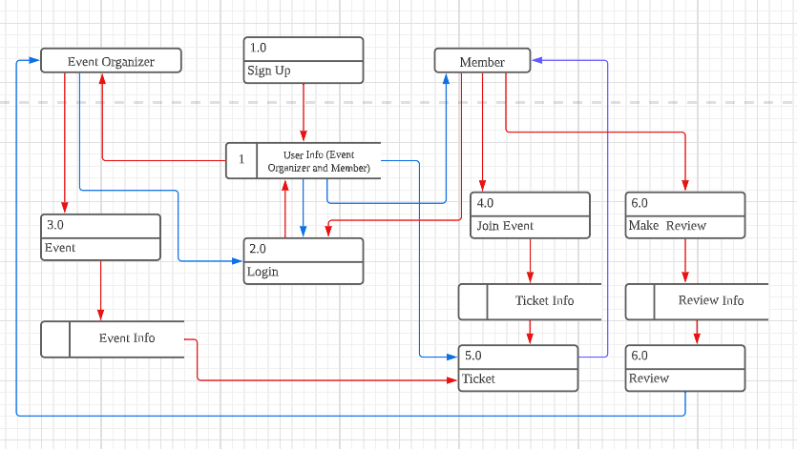

### 4.5.2 Use Case Diagram

### 4.5.3 Class Diagrams

### 4.5.4 Entity Relationship Diagram

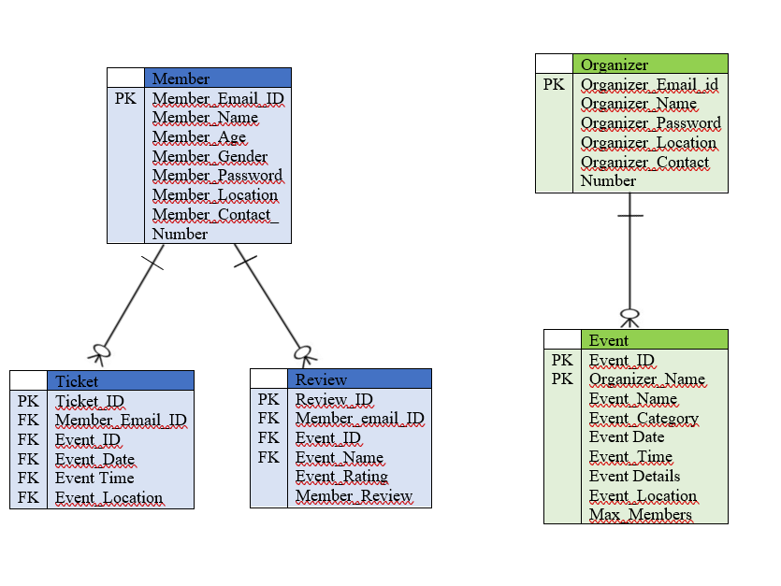

### 

### 

### 4.5.5 Data Dictionary

1. Member

| Attribute Name | Data Type | Length | Nullable | Primary Key | Default value | Constraints |
| --- | --- | --- | --- | --- | --- | --- |
| Member_Email_id | Varchar | 255 | Not Null | Yes | - | - |
| Member_Name | Varchar | 255 | Not Null | - | - | - |
| Member_Age | Integer | 3 | Not Null | - | - | >14 |
| Member_Gender | Char | 1 | Not Null | - | - | - |
| Member_Password | Varchar | 50 | Not Null | - | - | - |
| Member_Location | Varchar | 255 | Not Null | - | - | - |
| Member_Contact_  Number | Integer | 15 | Not Null | - | - | 0000000 -  9999999999 |

1. Organizer

| Attribute Name | Data Type | Length | Nullable | Primary Key | Default value | Constraints |
| --- | --- | --- | --- | --- | --- | --- |
| Email_id | Varchar | 255 | Not Null | Yes | - | - |
| Organizer_Name | Varchar | 255 | Not Null | - | - | - |
| Organizer_Password | Varchar | 50 | Not Null | - | - | - |
| Organizer_Location | Varchar | 255 | Not Null | - | - | - |
| Organizer_Contact Number | Integer | 15 | Not Null | - | - | 0000000 -  9999999999 |

1. Event

| Attribute Name | Data Type | Length | Nullable | Primary Key | Default value | Constraints |
| --- | --- | --- | --- | --- | --- | --- |
| Event_ID | Integer | 5 | Not Null | Yes |  | Between 00000-99999 |
| Organizer_Name | Varchar | 255 | Not Null | - | - | - |
| Event_Name | Varchar | 50 | Not Null |  | - | - |
| Event_Category | Varchar | 25 | Not Null | - | - | - |
| Event Date | Varchar | 25 | Not Null | - | - | - |
| Event_Time | Varchar | 25 | Not Null | - | - | - |
| Event Details | Varchar | 1000 | Not Null | - | - | > 200 |
| Event_Location | Varchar | 255 | Not Null | - | - | - |
| Max_Members | Integer | 3 | Not Null | - | - | >500 |

1. Ticket

| Attribute Name | Data Type | Length | Nullable | Primary Key | Default value | Constraints |
| --- | --- | --- | --- | --- | --- | --- |
| Ticket_ID | Integer | 8 | Not Null | Yes | - | Between 00000000-99999999 |
| Member_Email_ID | Varchar | 255 | Not Null | - | - | - |
| Event_ID | Integer | 5 | Not Null | - | - | Between 00000-99999 |
| Event_Date | Varchar |  | Not Null | - | - | - |
| Event Time | Varchar | 1000 | Not Null | - | - | - |
| Event_Location | Varchar | 255 | Not Null | - | - | - |

1. Review

| Attribute Name | Data Type | Length | Nullable | Primary Key | Default value | Constraints |
| --- | --- | --- | --- | --- | --- | --- |
| Member_email_ID | varchar | 5 | Not Null | Yes | - | - |
| Event_ID | Varchar | 255 | Not Null | - | - | - |
| Event_Name | Varchar | 255 | Not Null | - | - | - |
| Event_Rating | Integer | 1 | Not Null | - | 0 | <5 |
| Member_Review | Varchar | 1000 | Not Null | - | - | >50 |

## 4.6 Test Cases

### 4.6.1 Login Page

#### 4.6.1.1 Login Page (Member)

| Test Case ID | TC-01-001-0001 |
| --- | --- |
| Objective | To test if users will be able to login to the app with a valid email and password. |
| Pre-condition | The email and password of the member have been recorded into the database of the system. |
| Test Steps | 1. Enter a valid email.  2. Enter a valid password that matches the email.  3. Click on the “Login” button. |
| Input Data | An email that has been recorded into the database and a valid password that matches the email. |
| Expected Results | The system will authenticate the user and the user will be logged in and directed to the member home page |
| Actual Results | Matches the expected results. |
| Test Result | Pass |
| Remark | - |

| Test Case ID | TC-01-001-0002 |
| --- | --- |
| Objective | To test if the user will be able to login into the app with an empty email and password. |
| Pre-condition | The email and password of the member has been recorded into the database of the system. |
| Test Steps | 1. Leave the email field and password field empty.  2. Click on the “Login” button. |
| Input Data | The email and password text fields are left empty |
| Expected Results | The system will show a message which reminds the user to enter a email and password and the user is not granted access to the member home page |
| Actual Results | Matches the expected results. |
| Test Result | Pass |
| Remark | - |

| Test Case ID | TC-01-001-0003 |
| --- | --- |
| Objective | To test if the user will be able to login into the system with an incorrect email and password. |
| Pre-condition | The username and password of the member have been recorded in the database of the system. |
| Test Steps | 1. Enter an incorrect email.  2. Enter an incorrect password.  3. Click on the “Login” button. |
| Input Data | A set of an incorrect email with an incorrect password. |
| Expected Results | The system will show a message that informs the user that the email and password are incorrect and that the user is not granted access to the member home page. |
| Actual Results | Matches the expected results. |
| Test Result | Pass |
| Remark | - |

| Test Case ID | TC-01-001-0004 |
| --- | --- |
| Objective | To test if the user will be able to login to the system with a valid email but incorrect password. |
| Pre-condition | The email and password of the member have been recorded in the database of the system. |
| Test Steps | 1. Enter a valid email.  2. Enter a password that does not belong to the email.  3. Click on the “Login” button. |
| Input Data | A email that has been registered in the database and a password that does not belong to the email. |
| Expected Results | The system will show a message that informs the user that the email and password are incorrect and that the user is not granted access to the member home page. |
| Actual Results | Matches the expected results. |
| Test Result | Pass |
| Remark | - |

| Test Case ID | TC-01-001-0005 |
| --- | --- |
| Objective | To test if the user will be able to login to the system with the credentials of an organizer. |
| Pre-condition | The username and password of the member have been recorded in the database of the system. |
| Test Steps | 1. Enter a email that has been registered as an organizer.  2. Enter the associated password  3. Click on the “Login” button. |
| Input Data | An email and password that has been registered in the database but for an organizer. |
| Expected Results | The system will show a message which informs the user that the username and password are for an organizer account and will redirect the user to the organizer login page. |
| Actual Results | Matches the expected results. |
| Test Result | Pass |
| Remark | - |

#### 4.6.1.2 Login Page (Organizer)

| Test Case ID | TC-01-002-0001 |
| --- | --- |
| Objective | To test if organizers will be able to login to the app with a valid email and password. |
| Pre-condition | The email and password of the organizer have been recorded in the database of the system. |
| Test Steps | 1. Enter a valid email.  2. Enter a valid password that matches the email.  3. Click on the “Login” button. |
| Input Data | An email that has been recorded into the database and a valid password that matches the email. |
| Expected Results | The system will authenticate the user and the user will be logged in and directed to the organizer's home page |
| Actual Results | Matches the expected results. |
| Test Result | Pass |
| Remark | - |

| Test Case ID | TC-01-002-0002 |
| --- | --- |
| Objective | To test if the user will be able to login into the app with an empty email and password. |
| Pre-condition | The email and password of the member have been recorded in the database of the system. |
| Test Steps | 1. Leave the email field and password field empty.  2. Click on the “Login” button. |
| Input Data | The email and password text fields are left empty |
| Expected Results | The system will show a message which reminds the user to enter an email and password and the user is not granted access to the organizer's home page |
| Actual Results | Matches the expected results. |
| Test Result | Pass |
| Remark | - |

| Test Case ID | TC-01-002-0003 |
| --- | --- |
| Objective | To test if the user will be able to login into the system with an incorrect email and password. |
| Pre-condition | The username and password of the member have been recorded in the database of the system. |
| Test Steps | 1. Enter an incorrect email.  2. Enter an incorrect password.  3. Click on the “Login” button. |
| Input Data | A set of an incorrect email with an incorrect password. |
| Expected Results | The system will show a message that informs the user that the email and password are incorrect and that the user is not granted access to the organizer’s home page. |
| Actual Results | Matches the expected results. |
| Test Result | Pass |
| Remark | - |

| Test Case ID | TC-01-002-004 |
| --- | --- |
| Objective | To test if the user will be able to login to the system with a valid email but incorrect password. |
| Pre-condition | The email and password of the member have been recorded in the database of the system. |
| Test Steps | 1. Enter a valid email.  2. Enter a password that does not belong to the username.  3. Click on the “Login” button. |
| Input Data | A email that has been registered in the database and a password that do not belongs to the email. |
| Expected Results | The system will show a message which informs the user that the email and password are incorrect and that user is not granted access to the member home page. |
| Actual Results | Matches the expected results. |
| Test Result | Pass |
| Remark | - |

| Test Case ID | TC-01-002-0005 |
| --- | --- |
| Objective | To test if the user will be able to login to the system with the credentials of a member. |
| Pre-condition | The username and password of the member have been recorded in the database of the system. |
| Test Steps | 1. Enter an email address that has been registered as a member.  2. Enter the associated password  3. Click on the “Login” button. |
| Input Data | An email and password that has been registered in the database but for a member |
| Expected Results | The system will show a message that informs the user that the username and password are for a member account and will redirect the user to the member login page. |
| Actual Results | Matches the expected results. |
| Test Result | Pass |
| Remark | - |

### 4.6.2 Sign Up

#### 4.6.2.1 Organizer Sign Up

| Test Case ID | TC-02-001-0001 |
| --- | --- |
| Objective | To test if the user will be able to sign up as an organizer if any of the required fields (organizer name, email, contact number, password, and terms and conditions) is left empty/unchecked. |
| Pre-condition | None |
| Test Steps | 1. Leave the first text field empty (name)  2. Click the “Sign Up Button”  3. Repeat Process for all required information fields. |
| Input Data | The text fields are left empty. |
| Expected Results | The system will show a message that informs the user that associated information is empty and will not create an organizer account for the user. |
| Actual Results | Matches the expected results for all situations |
| Test Result | Pass |
| Remark | - |

| Test Case ID | TC-02-001-0002 |
| --- | --- |
| Objective | To test if the user will be able to sign up with an email in the wrong format. |
| Pre-condition | None |
| Test Steps | 1. Fill in all details and fill up the email with an incorrect input (Ex : joegmailcom)  2. Click the “Sign Up Button.” |
| Input Data | The email text field is filled with an email in the wrong format. |
| Expected Results | The system will show a message that informs the user that the email is in the wrong format and will not create an organizer for the user. |
| Actual Results | Matches the expected results. |
| Test Result | Pass |
| Remark | - |

| Test Case ID | TC-02-001-0003 |
| --- | --- |
| Objective | To test if the user will be able to sign up with a contact number in the wrong format (i.e This application only allows malaysian numbers) |
| Pre-condition | None |
| Test Steps | 1. fill up the contact number with an incorrect input (Ex : 009746278928)  2. Click the “Sign Up Button.” |
| Input Data | The contact number text field is filled with a number in the wrong format. |
| Expected Results | The system will show a message that informs the user that the contact number is in the wrong format and will not create an organizer account for the user. |
| Actual Results | Matches the expected results. |
| Test Result | Pass |
| Remark | - |

| Test Case ID | TC-02-001-0004 |
| --- | --- |
| Objective | To test if the user will be able to sign up with a password in the wrong format. (Less than 6 characters) |
| Pre-condition | None |
| Test Steps | 1. Fill in all details and fill up the password field with an incorrect input (Ex :ab)  2. Click the “Sign Up Button.” |
| Input Data | The password text field is filled with a password in the wrong format. |
| Expected Results | The system will show a message that informs the user that the password is in the wrong format and will not create an organizer account for the user. |
| Actual Results | Matches the expected results. |
| Test Result | Pass |
| Remark | - |

| Test Case ID | TC-02-001-0005 |
| --- | --- |
| Objective | To test if the user will be able to sign up if the password in the “Confirm Password” text field does not match with the password in the “Enter Password” text field. |
| Pre-condition | None |
| Test Steps | 1. Fill up the “Confirm Password” text field with a password that is not the same as the password in the “Enter Password” text field.  2. Click the “Sign Up Button.” |
| Input Data | The “Confirm Password” text field is filled with a password that does not match the “Enter Password” textfield. |
| Expected Results | The system will show a message that informs the user that the passwords do not match and will not create an organizer account for the user. |
| Actual Results | Matches the expected results. |
| Test Result | Pass |
| Remark | - |

#### 4.6.2.2 Member Sign Up

| Test Case ID | TC-02-002-0001 |
| --- | --- |
| Objective | To test if the user will be able to sign up as a member if any of the required fields (member name, email, contact number, password, and terms and conditions) is left empty/unchecked. |
| Pre-condition | None |
| Test Steps | 1. Leave the first text field empty (name)  2. Click the “Sign Up Button”  3. Repeat Process for all required information fields. |
| Input Data | The text fields are left empty. |
| Expected Results | The system will show a message that informs the user that associated information is empty and will not create a member account for the user. |
| Actual Results | Matches the expected results for all situations |
| Test Result | Pass |
| Remark | - |

| Test Case ID | TC-02-002-0002 |
| --- | --- |
| Objective | To test if the user will be able to sign up with an email in the wrong format. |
| Pre-condition | None |
| Test Steps | 1. Fill in all details and fill up the email with an incorrect input (Ex : joegmailcom)  2. Click the “Sign Up Button.” |
| Input Data | The email text field is filled with an email in the wrong format. |
| Expected Results | The system will show a message that informs the user that the email is in the wrong format and will not create a member account for the user. |
| Actual Results | Matches the expected results. |
| Test Result | Pass |
| Remark | - |

| Test Case ID | TC-02-002-0003 |
| --- | --- |
| Objective | To test if the user will be able to sign up with a contact number in the wrong format (i.e This application only allows malaysian numbers) |
| Pre-condition | None |
| Test Steps | 1. fill up the contact number with an incorrect input (Ex : 009746278928)  2. Click the “Sign Up Button.” |
| Input Data | The contact number text field is filled with a number in the wrong format. |
| Expected Results | The system will show a message that informs the user that the contact number is in the wrong format and will not create a member account for the user. |
| Actual Results | Matches the expected results. |
| Test Result | Pass |
| Remark | - |

| Test Case ID | TC-02-002-0004 |
| --- | --- |
| Objective | To test if the user will be able to sign up with a password in the wrong format. (Less than 6 characters) |
| Pre-condition | None |
| Test Steps | 1. Fill in all details and fill up the password field with an incorrect input (Ex :ab)  2. Click the “Sign Up Button.” |
| Input Data | The password text field is filled with a password in the wrong format. |
| Expected Results | The system will show a message that informs the user that the password is in the wrong format and will not create a member account for the user. |
| Actual Results | Matches the expected results. |
| Test Result | Pass |
| Remark | - |

| Test Case ID | TC-02-002-0005 |
| --- | --- |
| Objective | To test if the user will be able to sign up if the password in the “Confirm Password” text field does not match with the password in the “Enter Password” text field. |
| Pre-condition | None |
| Test Steps | 1. Fill up the “Confirm Password” text field with a password that is not same as the password in the “Enter Password” text field.  2. Click the “Sign Up Button.” |
| Input Data | The “Confirm Password” text field is filled with a password that does not match the “Enter Password” textfield. |
| Expected Results | The system will show a message that informs the user that the passwords do not match and will not create a member account for the user. |
| Actual Results | Matches the expected results. |
| Test Result | Pass |
| Remark | - |

| Test Case ID | TC-02-002-0007 |
| --- | --- |
| Objective | To test if the user will be able to sign up if he does not select a location in the “Set Location” page |
| Pre-condition | The user has filled up the details in the previous page (Member Info Page) |
| Test Steps | 1. Click the Create account button without setting a location. |
| Input Data | None |
| Expected Results | The system should show a message that informs the user that they have not set a location and a member account will not be created. |
| Actual Results | Matches the expected results. |
| Test Result | Pass |
| Remark | - |

| Test Case ID | TC-02-002-0008 |
| --- | --- |
| Objective | To test whether the “Use my current location” feature works. (User’s current location is saved and the map fragment’s pointer moves to the current location.) |
| Pre-condition | The user has filled up the details in the previous page (Member Info Page) |
| Test Steps | 1. Click the “Use my current location” on the page. |
| Input Data | None |
| Expected Results | The system should:   * Save the user’s **current** location. * Saves the location in the database. * Map fragment will move the pointer to the user’s current location. |
| Actual Results | Matches the expected results. |
| Test Result | Pass |
| Remark | - |

| Test Case ID | TC-02-002-0009 |
| --- | --- |
| Objective | To test whether the “Manually Set Location” feature works. (The user is allowed to search his location and select a location based on the search.) |
| Pre-condition | The user has filled up the details in the previous page (Member Info Page) |
| Test Steps | 1. Click the “Manually Type in Location” button on the page.  2. Once the popup appears, type your location in the text field on the top of the popup and click enter.  3. Choose your location among the list of locations that show up under the text field. |
| Input Data | Users location in the text field on top of the popup. |
| Expected Results | The system should:   * Pop up appropriate dialog box when button is clicked * Show appropriate locations based on the search. * Saves the location in the database. |
| Actual Results | Matches the expected results. |
| Test Result | Pass |
| Remark | - |

### 4.6.3 Organizer Pages

#### 4.6.3.1 “Add Event” Page

| Test Case ID | TC-03-001 |
| --- | --- |
| Objective | To test if the user will be able to create an event if any of the required fields (Event name, time category, date, maximum member, additional info, location) is left empty. |
| Pre-condition | None |
| Test Steps | 1. Leave the first text field empty (name)  2. Click the “Create Event” Button  3. Repeat Process for all required information fields. |
| Input Data | The text fields are left empty. |
| Expected Results | The system should show a message that informs the user that associated information is empty and will not create an event. |
| Actual Results | Matches the expected results for all situations |
| Test Result | Pass |
| Remark | - |

#### 

| Test Case ID | TC-03-002 |
| --- | --- |
| Objective | To test if the user can select a date before the current date. |
| Pre-condition | None |
| Test Steps | 1. Attempt to select a date before the current date in the date drop down. |
| Input Data | None |
| Expected Results | The system should not allow the user to do so |
| Actual Results | Matches the expected results. |
| Test Result | Pass |
| Remark | - |

#### 

| Test Case ID | TC-03-003 |
| --- | --- |
| Objective | To test if the user will be able to add an event banner. |
| Pre-condition | None |
| Test Steps | 1. Click the Image view under the “Event Banner” Text Field and select image from your phone’s storage.  2. Fill up all other required information  3. Click the “Create Event” Button. |
| Input Data | Image and other |
| Expected Results | The system will show the selected image in all instances where the image is to be shown (Ex: in the “my events page”) |
| Actual Results | Matches the expected results. |
| Test Result | Pass |
| Remark | - |

| Test Case ID | TC-03-004 |
| --- | --- |
| Objective | To test whether the “Set Event Location” feature works. (The user is allowed to search his location and select a location based on the search.) |
| Pre-condition | None |
| Test Steps | 1. Click the “Set Event Location” button on the page.  2. Once the popup appears, type your location in the text field on the top of the popup and click enter.  3. Choose your location among the list of locations that show up under the text field. |
| Input Data | Location of the event in the text field on top of the popup. |
| Expected Results | The system should:   * Pop up appropriate dialog box when button is clicked * Show appropriate locations based on the search. * Saves the location of the event. * Show a message that informs the user that the location has been saved. |
| Actual Results | Matches the expected results. |
| Test Result | Pass |
| Remark | - |

#### 

#### 

#### 4.6.3.2 “My Events” Page.

| Test Case ID | TC-04-001 |
| --- | --- |
| Objective | To test if the events created by the organizer show up on this page |
| Pre-condition | The organizer has created one or more events. |
| Test Steps | 1. Click the “My events” on the bottom navigation view. |
| Input Data | None |
| Expected Results | The system should show events **the logged in organizer has created** beyond the current date and time on the page. |
| Actual Results | Matches the expected results. |
| Test Result | Pass |
| Remark | - |

| Test Case ID | TC-04-002 |
| --- | --- |
| Objective | To test if the organizer can delete events. |
| Pre-condition | The organizer has created one or more images. |
| Test Steps | 1. Click the “My events” on the bottom navigation view.  2. Click the delete button on the event you want to delete. |
| Input Data | None |
| Expected Results | The system should:   * Delete the data of the event from the database. * Event does not appear on the page anymore. |
| Actual Results | Matches the expected results. |
| Test Result | Pass |
| Remark | - |

#### 

#### 4.6.3.3 “Reviews” Page.

| Test Case ID | TC-05-001 |
| --- | --- |
| Objective | To test if the organizer can see reviews from members for an event he/she has created. |
| Pre-condition | The organizer has created one or more events which has been reviewed by a member. |
| Test Steps | 1. Click the “Reviews” on the bottom navigation view. |
| Input Data | None |
| Expected Results | The system should fetch review data from the database and only show reviews for the events that the logged in organizer has created on the page. |
| Actual Results | Matches the expected results. |
| Test Result | Pass |
| Remark | - |

#### 

#### 

#### 

#### 

#### 

#### 

#### 4.6.3.4 Profile Page.

| Test Case ID | TC-06-001 |
| --- | --- |
| Objective | To test if the profile page shows the information of the logged in organizer. |
| Pre-condition | The organizer is logged in. |
| Test Steps | 1. Click the profile icon on the top left corner of any page. |
| Input Data | None |
| Expected Results | The system should fetch the data of the logged in organizer and display it. |
| Actual Results | Matches the expected results. |
| Test Result | Pass |
| Remark | - |

| Test Case ID | TC-06-002 |
| --- | --- |
| Objective | To test if the profile page allows the organizer to change his profile picture. |
| Pre-condition | The organizer is logged in. |
| Test Steps | 1. Click the profile icon on the top left corner of any page.  2. Click the “Set Organizer Profile Picture” Button.  3. Choose an image and click the Safe Info Button. |
| Input Data | An image for a new profile picture. |
| Expected Results | The system should update the profile picture in the database for the logged in organizer. |
| Actual Results | Matches the expected results. |
| Test Result | Pass |
| Remark | - |

## 

### 4.6.4 Member Pages

#### 4.6.4.1 Explore Page.

| Test Case ID | TC-07-001 |
| --- | --- |
| Objective | To test if the profile page shows all events that organizers have created that have an event date and time beyond the current date and time. |
| Pre-condition | One or more events are created by organizers. (Preferably some events whose event date and time is beyond and after the current time) |
| Test Steps | 1. Click the explore element on the bottom navigation bar. |
| Input Data | None |
| Expected Results | The system should fetch the data of the events of all organizers whose event date and time is beyond the current date and time. |
| Actual Results | Matches the expected results. |
| Test Result | Pass |
| Remark | This test was carried out and passed for the home page as well but not repeated to prevent redundancy. |

#### 

| Test Case ID | TC-07-002 |
| --- | --- |
| Objective | To test if a dialog pops up when an event is tapped. |
| Pre-condition | One or more events are created by organizers. |
| Test Steps | 1. Click the explore element on the bottom navigation bar.  2. Tap an event. |
| Input Data | None |
| Expected Results | The system should correctly fetch the corresponding data of the event clicked and also show a button the allows the user to join the event. |
| Actual Results | Matches the expected results. |
| Test Result | Pass |
| Remark | This test was carried out and passed for the home page as well but not repeated to prevent redundancy. |

#### 

| Test Case ID | TC-07-003 |
| --- | --- |
| Objective | To test if the user can join the event from the dialog pop up. |
| Pre-condition | One or more events are created by organizers. |
| Test Steps | 1. Click the explore element on the bottom navigation bar.  2. Tap an event.  3. Tap the Join event button on the pop up that shows up. |
| Input Data | None |
| Expected Results | The system should add the member as an attendee of the event (by adding him to the ticket table in the database) and should remove the event from the page (to prevent the use from joining again. |
| Actual Results | Matches the expected results. |
| Test Result | Pass |
| Remark | This test was carried out and passed for the home page as well but not repeated to prevent redundancy. |

#### 4.6.4.2 Home Page.

| Test Case ID | TC-08-001 |
| --- | --- |
| Objective | To test if the home page displays events within 10km of the user’s location |
| Pre-condition | One or more events are created by organizers that are within the range of 10km of the user’s location and vice versa. |
| Test Steps | 1. Click the home element on the bottom navigation bar. |
| Input Data | None |
| Expected Results | The system should only show the events within the 10km radius. |
| Actual Results | Matches the expected results. |
| Test Result | Pass |
| Remark | - |

#### 

| Test Case ID | TC-08-002 |
| --- | --- |
| Objective | To test if the home page displays events based on categories. (Home page should should display sports, educational and leisure events under the appropriate text views) |
| Pre-condition | 3 or more events are created by organizers and at least one event each in the above mentioned categories. |
| Test Steps | 1. Click the home element on the bottom navigation bar. |
| Input Data | None |
| Expected Results | The system should only show the events under the right textviews. |
| Actual Results | Matches the expected results. |
| Test Result | Pass |
| Remark | For context, the home page has three text views that indicate the category of events that should be displayed under it. |

#### 

#### 

#### 

#### 

#### 

#### 

#### 

#### 

#### 4.6.4.3 My Events Page.

#### 

| Test Case ID | TC-09-001 |
| --- | --- |
| Objective | To test if the “My events” page shows the events the logged in user has signed up for under the appropriate text view . |
| Pre-condition | The logged in user has signed up for two or more events. One of which is upcoming and one which has passed. |
| Test Steps | 1. Click the “My events” element on the bottom navigation bar. |
| Input Data | None |
| Expected Results | The system should:   * Show the events the logged in user has signed up. * The events are under the appropriate text view. |
| Actual Results | Matches the expected results. |
| Test Result | Pass |
| Remark | For context, upcoming events should be under the “Upcoming events” text view and events that have passed should be under the “Past Events” textview. |

#### 

| Test Case ID | TC-09-002 |
| --- | --- |
| Objective | To test if the events under the “Upcoming events” pop up a ticket dialog when they are tapped. |
| Pre-condition | The logged in user has signed up for two or more events. One of which is upcoming and one which has passed. |
| Test Steps | 1. Tap the “My events” element on the bottom navigation bar.  2. Tap a event under the “Upcoming Event” |
| Input Data | None |
| Expected Results | The system should pop up an ticket dialog when an event is tapped. |
| Actual Results | Matches the expected results. |
| Test Result | Pass |
| Remark | - |

#### 

| Test Case ID | TC-09-003 |
| --- | --- |
| Objective | To test if the events under the “Past events” pop up a review event when they are tapped. |
| Pre-condition | The logged in user has signed up for two or more events. One of which is upcoming. |
| Test Steps | 1. Tap the “My events” element on the bottom navigation bar.  2. Tap a event under the “Past Events” |
| Input Data | None |
| Expected Results | The system should pop up an review dialog when the event is tapped |
| Actual Results | Matches the expected results. |
| Test Result | Pass |
| Remark |  |

#### 

| Test Case ID | TC-09-004 |
| --- | --- |
| Objective | To test if the users can successfully submit an review |
| Pre-condition | The logged in user has signed up for two or more events. One of which is passed. |
| Test Steps | 1. Tap the “My events” element on the bottom navigation bar.  2. Tap a event under the “Past Events” |
| Input Data | None |
| Expected Results | The user should be able to submit a review for the corresponding events and the review should be sent to the database. |
| Actual Results | Matches the expected results. |
| Test Result | Pass |
| Remark |  |

#### 4.6.4.4 Profile Page.

| Test Case ID | TC-10-001 |
| --- | --- |
| Objective | To test if the profile page shows the information of the logged in member. |
| Pre-condition | The member is logged in. |
| Test Steps | 1. Click the profile icon on the top left corner of any page. |
| Input Data | None |
| Expected Results | The system should fetch the data of the logged in member and display it. |
| Actual Results | Matches the expected results. |
| Test Result | Pass |
| Remark | - |

| Test Case ID | TC-06-002 |
| --- | --- |
| Objective | To test if the profile page allows the member to change his profile picture. |
| Pre-condition | The member is logged in. |
| Test Steps | 1. Click the profile icon on the top left corner of any page.  2. Click the “Set Member Profile Picture” Button.  3. Choose an image and click the Safe Info Button. |
| Input Data | An image for a new profile picture. |
| Expected Results | The system should update the profile picture in the database for the logged in member and display the new image in all scenarios. |
| Actual Results | Matches the expected results. |
| Test Result | Pass |
| Remark | - |

## 

## 

## 

## 

## 

# 5. Conclusion and Future Work

An app that allows users to create and join events was developed during the timeline of this project. The project’s objectives were achieved and the scope of the project has also been covered through the app. Apps with similar objectives were reviewed to get a better understanding of what needs to be implemented and avoided to successfully achieve this project's objectives. The tools to develop the app based on the objective were then chosen and the appropriate model diagram was created to get a visual understanding of the dataflow in the app. This was followers by designing the user interface. Once that was completed, the app was then developed and tested through different test scenarios and ready to be tested by other users.  
  
Data collected through the questionnaire gave valuable insights regarding the app. Firstly, all the app functions on both member and organizer were confirmed to be functional as 100% of the responses regarding the working of the functions of the app were positive responses.   
  
However, with that being said this is still the first version and requires plenty of changes before it can be released to the public. Currently the app is well suited for a smaller audience and may have performance issues under higher loads. The questionnaire also revealed some important features such as organizer’s being able to notify members regarding changes in event details and member’s being able to leave events and see reviews left by other members. In the future, these features can be implemented to make the app overall more effective in reaching its objective.

## 

# 

# 

# 

# 6. References

[1] Amutha, D. (2020) “Covid-19 epidemic and its impact on economy and Society,” *SSRN Electronic Journal* [Preprint]. Available at: https://doi.org/10.2139/ssrn.3737535.

[2] J. Quigley, “Highlights and milestones from 20 years of Meetup,” *Meetup Blog*, 07-Jun-2022. [Online]. Available: https://www.meetup.com/blog/highlights-and-milestones-from-20-years-of-meetup/. [Accessed: 10-Oct-2022].

[3] “Meetup: Find events near you - apps on Google Play,” *Google*. [Online]. Available: https://play.google.com/store/apps/details?id=com.meetup&hl=en&gl=US. [Accessed: 12-Oct-2022].

[4] “Eventbrite overview,” *GetApp*. [Online]. Available: https://www.getapp.com/customer-management-software/a/eventbrite/. [Accessed: 12-Oct-2022].

[5] M. LLC, “Meetup: Local groups & events,” *App Store*, 13-Jun-2010. [Online]. Available: https://apps.apple.com/us/app/meetup-local-groups-events/id375990038. [Accessed: 16-Oct-2022].

[6] “Eventbrite – discover events - apps on Google Play,” *Google*. [Online]. Available: https://play.google.com/store/apps/details?id=com.eventbrite.attendee&hl=en&gl=US. [Accessed: 16-Oct-2022].

[7] Eventbrite, “Eventbrite,” *App Store*, 18-Dec-2011. [Online]. Available: https://apps.apple.com/us/app/eventbrite/id487922291. [Accessed: 25-Oct-2022].

[8] Amitech, “All events in City,” *App Store*, 14-Dec-2011. [Online]. Available: https://apps.apple.com/us/app/all-events-in-city/id488116646. [Accessed: 27-Oct-2022].

[9]. “All events in city - discover - apps on Google Play,” *Google*. [Online]. Available: https://play.google.com/store/apps/details?id=com.amitech.allevents&hl=en_US&gl=US. [Accessed: 30-Oct-2022].

[10] R. Perera, “What is Figma? (and how to use Figma for beginners),” *Theme Junkie*, 14-Sep-2020. [Online]. Available: https://www.theme-junkie.com/what-is-figma/. [Accessed: 30-Oct-2022].

[11] “MVC Architecture: A detailed insight to the modern web applications ...” [Online]. Available: https://crimsonpublishers.com/prsp/pdf/PRSP.000505.pdf. [Accessed: 30-Oct-2022].